**ETL&Batch Processing project**

**Data Ingestion from the RDS to HDFS using Sqoop**

1. **Command for importing database sqoop**

sqoop import --connect jdbc:mysql://upgradawsrds.cpclxrkdvwmz.us-east-1.rds.amazonaws.com/indiaahs2012_13 --username upgraduser --password upgraduser --table Key_indicator_districtwise --fields-terminated-by ',' --null-string 'NA' --null-non-string '\\N' --target-dir /user/cloudera/sqoop/indiaahs2012_13/key_indicator_districtwise

1. **Command to see the list of imported data**

hdfs dfs -ls sqoop/indiaahs2012_13/key_indicator_districtwise

**External table creation in Hive and loading the ingested data into it. Data ingestion verification.**

1. **Command to create the external table**

create external table IF NOT EXISTS Key_indicator_districtwise(`ID` bigint,

`State_Name` varchar(100),

`State_District_Name` varchar(100),

`AA_Sample_Units_Total` double,

`AA_Sample_Units_Rural` double,

`AA_Sample_Units_Urban` double,

`AA_Households_Total` double,

`AA_Households_Rural` double,

`AA_Households_Urban` double,

`AA_Population_Total` double,

`AA_Population_Rural` double,

`AA_Population_Urban` double,

`AA_Ever_Married_Women_Aged_15_49_Years_Total` double,

`AA_Ever_Married_Women_Aged_15_49_Years_Rural` double,

`AA_Ever_Married_Women_Aged_15_49_Years_Urban` double,

`AA_Currently_Married_Women_Aged_15_49_Years_Total` double,

`AA_Currently_Married_Women_Aged_15_49_Years_Rural` double,

`AA_Currently_Married_Women_Aged_15_49_Years_Urban` double,

`AA_Children_12_23_Months_Total` double,

`AA_Children_12_23_Months_Rural` double,

`AA_Children_12_23_Months_Urban` double,

`BB_Average_Household_Size_Sc_Total` double,

`BB_Average_Household_Size_Sc_Rural` double,

`BB_Average_Household_Size_Sc_Urban` double,

`BB_Average_Household_Size_St_Total` double,

`BB_Average_Household_Size_St_Rural` double,

`BB_Average_Household_Size_St_Urban` double,

`BB_Average_Household_Size_All_Total` double,

`BB_Average_Household_Size_All_Rural` double,

`BB_Average_Household_Size_All_Urban` double,

`BB_Population_Below_Age_15_Years_Total` double,

`BB_Population_Below_Age_15_Years_Rural` double,

`BB_Population_Below_Age_15_Years_Urban` double,

`BB_Dependency_Ratio_Total` double,

`BB_Dependency_Ratio_Rural` double,

`BB_Dependency_Ratio_Urban` double,

`BB_Currently_Married_Illiterate_Women_Aged_15_49_Years_Total` double,

`BB_Currently_Married_Illiterate_Women_Aged_15_49_Years_Rural` double,

`BB_Currently_Married_Illiterate_Women_Aged_15_49_Years_Urban` double,

`CC_Sex_Ratio_At_Birth_Total` double,

`CC_Sex_Ratio_At_Birth_Rural` double,

`CC_Sex_Ratio_At_Birth_Urban` double,

`CC_Sex_Ratio_0_4_Years_Total` double,

`CC_Sex_Ratio_0_4_Years_Rural` double,

`CC_Sex_Ratio_0_4_Years_Urban` double,

`CC_Sex_Ratio_All_Ages_Total` double,

`CC_Sex_Ratio_All_Ages_Rural` double,

`CC_Sex_Ratio_All_Ages_Urban` double,

`DD_Person_Total` double,

`DD_Person_Rural` double,

`DD_Person_Urban` double,

`DD_Male_Total` double,

`DD_Male_Rural` double,

`DD_Male_Urban` double,

`DD_Female_Total` double,

`DD_Female_Rural` double,

`DD_Female_Urban` double,

`EE_Marriages_Among_Females_Below_Legal_Age_18_Years_Total` double,

`EE_Marriages_Among_Females_Below_Legal_Age_18_Years_Rural` double,

`EE_Marriages_Among_Females_Below_Legal_Age_18_Years_Urban` double,

`EE_Marriages_Among_Males_Below_Legal_Age_21_Years_Total` double,

`EE_Marriages_Among_Males_Below_Legal_Age_21_Years_Rural` double,

`EE_Marriages_Among_Males_Below_Legal_Age_21_Years_Urban` double,

`EE_Married_Women_20_24_Years_Married_Before_18_Years_Total` double,

`EE_Married_Women_20_24_Years_Married_Before_18_Years_Rural` double,

`EE_Married_Women_20_24_Years_Married_Before_18_Years_Urban` double,

`EE_Married_Men_25_29_Years_Married_Before_21_Years_Total` double,

`EE_Married_Men_25_29_Years_Married_Before_21_Years_Rural` double,

`EE_Married_Men_25_29_Years_Married_Before_21_Years_Urban` double,

`EE_Mean_Age_At_Marriage_Male_Total` double,

`EE_Mean_Age_At_Marriage_Male_Rural` double,

`EE_Mean_Age_At_Marriage_Male_Urban` double,

`EE_Mean_Age_At_Marriage_Female_Total` double,

`EE_Mean_Age_At_Marriage_Female_Rural` double,

`EE_Mean_Age_At_Marriage_Female_Urban` double,

`FF_Children_Attending_School_Age_6_17_Years_Person_Total` double,

`FF_Children_Attending_School_Age_6_17_Years_Person_Rural` double,

`FF_Children_Attending_School_Age_6_17_Years_Person_Urban` double,

`FF_Children_Attending_School_Age_6_17_Years_Male_Total` double,

`FF_Children_Attending_School_Age_6_17_Years_Male_Rural` double,

`FF_Children_Attending_School_Age_6_17_Years_Male_Urban` double,

`FF_Children_Attending_School_Age_6_17_Years_Female_Total` double,

`FF_Children_Attending_School_Age_6_17_Years_Female_Rural` double,

`FF_Children_Attending_School_Age_6_17_Years_Female_Urban` double,

`FF_Children_Attended_Before_Drop_Out_Age_6_17_Years_Person_Total` double,

`FF_Children_Attended_Before_Drop_Out_Age_6_17_Years_Person_Rural` double,

`FF_Children_Attended_Before_Drop_Out_Age_6_17_Years_Person_Urban` double,

`FF_Children_Attended_Before_Drop_Out_Age_6_17_Years_Male_Total` double,

`FF_Children_Attended_Before_Drop_Out_Age_6_17_Years_Male_Rural` double,

`FF_Children_Attended_Before_Drop_Out_Age_6_17_Years_Male_Urban` double,

`FF_Children_Attended_Before_Drop_Out_Age_6_17_Years_Female_Total` double,

`FF_Children_Attended_Before_Drop_Out_Age_6_17_Years_Female_Rural` double,

`FF_Children_Attended_Before_Drop_Out_Age_6_17_Years_Female_Urban` double,

`GG_Children_Aged_5_14_Years_Engaged_In_Work_Person_Total` double,

`GG_Children_Aged_5_14_Years_Engaged_In_Work_Person_Rural` double,

`GG_Children_Aged_5_14_Years_Engaged_In_Work_Person_Urban` double,

`GG_Children_Aged_5_14_Years_Engaged_In_Work_Male_Total` double,

`GG_Children_Aged_5_14_Years_Engaged_In_Work_Male_Rural` double,

`GG_Children_Aged_5_14_Years_Engaged_In_Work_Male_Urban` double,

`GG_Children_Aged_5_14_Years_Engaged_In_Work_Female_Total` double,

`GG_Children_Aged_5_14_Years_Engaged_In_Work_Female_Rural` double,

`GG_Children_Aged_5_14_Years_Engaged_In_Work_Female_Urban` double,

`GG_Work_Participation_Rate_15_Years_And_Above_Person_Total` double,

`GG_Work_Participation_Rate_15_Years_And_Above_Person_Rural` double,

`GG_Work_Participation_Rate_15_Years_And_Above_Person_Urban` double,

`GG_Work_Participation_Rate_15_Years_And_Above_Male_Total` double,

`GG_Work_Participation_Rate_15_Years_And_Above_Male_Rural` double,

`GG_Work_Participation_Rate_15_Years_And_Above_Male_Urban` double,

`GG_Work_Participation_Rate_15_Years_And_Above_Female_Total` double,

`GG_Work_Participation_Rate_15_Years_And_Above_Female_Rural` double,

`GG_Work_Participation_Rate_15_Years_And_Above_Female_Urban` double,

`HH_Prevalence_Disability_Per_100000_Population_Person_Total` double,

`HH_Prevalence_Disability_Per_100000_Population_Person_Rural` double,

`HH_Prevalence_Disability_Per_100000_Population_Person_Urban` double,

`HH_Prevalence_Disability_Per_100000_Population_Male_Total` double,

`HH_Prevalence_Disability_Per_100000_Population_Male_Rural` double,

`HH_Prevalence_Disability_Per_100000_Population_Male_Urban` double,

`HH_Prevalence_Disability_Per_100000_Population_Female_Total` double,

`HH_Prevalence_Disability_Per_100000_Population_Female_Rural` double,

`HH_Prevalence_Disability_Per_100000_Population_Female_Urban` double,

`II_Injured_By_Type_Of_Treatment_Per_100000_Severe_Person_Total` double,

`II_Injured_By_Type_Of_Treatment_Per_100000_Severe_Person_Rural` double,

`II_Injured_By_Type_Of_Treatment_Per_100000_Severe_Person_Urban` double,

`II_Injured_By_Type_Of_Treatment_Per_100000_Severe_Male_Total` double,

`II_Injured_By_Type_Of_Treatment_Per_100000_Severe_Male_Rural` double,

`II_Injured_By_Type_Of_Treatment_Per_100000_Severe_Male_Urban` double,

`II_Injured_By_Type_Of_Treatment_Per_100000_Severe_Female_Total` double,

`II_Injured_By_Type_Of_Treatment_Per_100000_Severe_Female_Rural` double,

`II_Injured_By_Type_Of_Treatment_Per_100000_Severe_Female_Urban` double,

`II_Injured_By_Type_Of_Treatment_Per_100000_Major_Person_Total` double,

`II_Injured_By_Type_Of_Treatment_Per_100000_Major_Person_Rural` double,

`II_Injured_By_Type_Of_Treatment_Per_100000_Major_Person_Urban` double,

`II_Injured_By_Type_Of_Treatment_Per_100000_Major_Male_Total` double,

`II_Injured_By_Type_Of_Treatment_Per_100000_Major_Male_Rural` double,

`II_Injured_By_Type_Of_Treatment_Per_100000_Major_Male_Urban` double,

`II_Injured_By_Type_Of_Treatment_Per_100000_Major_Female_Total` double,

`II_Injured_By_Type_Of_Treatment_Per_100000_Major_Female_Rural` double,

`II_Injured_By_Type_Of_Treatment_Per_100000_Major_Female_Urban` double,

`II_Injured_By_Type_Of_Treatment_Per_100000_Minor_Person_Total` double,

`II_Injured_By_Type_Of_Treatment_Per_100000_Minor_Person_Rural` double,

`II_Injured_By_Type_Of_Treatment_Per_100000_Minor_Person_Urban` double,

`II_Injured_By_Type_Of_Treatment_Per_100000_Minor_Male_Total` double,

`II_Injured_By_Type_Of_Treatment_Per_100000_Minor_Male_Rural` double,

`II_Injured_By_Type_Of_Treatment_Per_100000_Minor_Male_Urban` double,

`II_Injured_By_Type_Of_Treatment_Per_100000_Minor_Female_Total` double,

`II_Injured_By_Type_Of_Treatment_Per_100000_Minor_Female_Rural` double,

`II_Injured_By_Type_Of_Treatment_Per_100000_Minor_Female_Urban` double,

`JJ_Acute_Illness_Per_100000_Diarrhoea_Dysentery_Person_Total` double,

`JJ_Acute_Illness_Per_100000_Diarrhoea_Dysentery_Person_Rural` double,

`JJ_Acute_Illness_Per_100000_Diarrhoea_Dysentery_Person_Urban` double,

`JJ_Acute_Illness_Per_100000_Diarrhoea_Dysentery_Male_Total` double,

`JJ_Acute_Illness_Per_100000_Diarrhoea_Dysentery_Male_Rural` double,

`JJ_Acute_Illness_Per_100000_Diarrhoea_Dysentery_Male_Urban` double,

`JJ_Acute_Illness_Per_100000_Diarrhoea_Dysentery_Female_Total` double,

`JJ_Acute_Illness_Per_100000_Diarrhoea_Dysentery_Female_Rural` double,

`JJ_Acute_Illness_Per_100000_Diarrhoea_Dysentery_Female_Urban` double,

`JJ_Acute_Illness_Per_100000_Respiratory_Infection_Person_Total` double,

`JJ_Acute_Illness_Per_100000_Respiratory_Infection_Person_Rural` double,

`JJ_Acute_Illness_Per_100000_Respiratory_Infection_Person_Urban` double,

`JJ_Acute_Illness_Per_100000_Respiratory_Infection_Male_Total` double,

`JJ_Acute_Illness_Per_100000_Respiratory_Infection_Male_Rural` double,

`JJ_Acute_Illness_Per_100000_Respiratory_Infection_Male_Urban` double,

`JJ_Acute_Illness_Per_100000_Respiratory_Infection_Female_Total` double,

`JJ_Acute_Illness_Per_100000_Respiratory_Infection_Female_Rural` double,

`JJ_Acute_Illness_Per_100000_Respiratory_Infection_Female_Urban` double,

`JJ_Acute_Illness_Per_100000_Fever_All_Types_Person_Total` double,

`JJ_Acute_Illness_Per_100000_Fever_All_Types_Person_Rural` double,

`JJ_Acute_Illness_Per_100000_Fever_All_Types_Person_Urban` double,

`JJ_Acute_Illness_Per_100000_Fever_All_Types_Male_Total` double,

`JJ_Acute_Illness_Per_100000_Fever_All_Types_Male_Rural` double,

`JJ_Acute_Illness_Per_100000_Fever_All_Types_Male_Urban` double,

`JJ_Acute_Illness_Per_100000_Fever_All_Types_Female_Total` double,

`JJ_Acute_Illness_Per_100000_Fever_All_Types_Female_Rural` double,

`JJ_Acute_Illness_Per_100000_Fever_All_Types_Female_Urban` double,

`JJ_Acute_Illness_Per_100000_Any_Type_Of_Acute_Person_Total` double,

`JJ_Acute_Illness_Per_100000_Any_Type_Of_Acute_Person_Rural` double,

`JJ_Acute_Illness_Per_100000_Any_Type_Of_Acute_Person_Urban` double,

`JJ_Acute_Illness_Per_100000_Any_Type_Of_Acute_Male_Total` double,

`JJ_Acute_Illness_Per_100000_Any_Type_Of_Acute_Male_Rural` double,

`JJ_Acute_Illness_Per_100000_Any_Type_Of_Acute_Male_Urban` double,

`JJ_Acute_Illness_Per_100000_Any_Type_Of_Acute_Female_Total` double,

`JJ_Acute_Illness_Per_100000_Any_Type_Of_Acute_Female_Rural` double,

`JJ_Acute_Illness_Per_100000_Any_Type_Of_Acute_Female_Urban` double,

`JJ_Acute_Illness_And_Taking_Treatment_Person_Total` double,

`JJ_Acute_Illness_And_Taking_Treatment_Person_Rural` double,

`JJ_Acute_Illness_And_Taking_Treatment_Person_Urban` double,

`JJ_Acute_Illness_And_Taking_Treatment_Male_Total` double,

`JJ_Acute_Illness_And_Taking_Treatment_Male_Rural` double,

`JJ_Acute_Illness_And_Taking_Treatment_Male_Urban` double,

`JJ_Acute_Illness_And_Taking_Treatment_Female_Total` double,

`JJ_Acute_Illness_And_Taking_Treatment_Female_Rural` double,

`JJ_Acute_Illness_And_Taking_Treatment_Female_Urban` double,

`JJ_Acute_Illness_And_Taking_Treatment_Government_Person_Total` double,

`JJ_Acute_Illness_And_Taking_Treatment_Government_Person_Rural` double,

`JJ_Acute_Illness_And_Taking_Treatment_Government_Person_Urban` double,

`JJ_Acute_Illness_And_Taking_Treatment_Government_Male_Total` double,

`JJ_Acute_Illness_And_Taking_Treatment_Government_Male_Rural` double,

`JJ_Acute_Illness_And_Taking_Treatment_Government_Male_Urban` double,

`JJ_Acute_Illness_And_Taking_Treatment_Government_Female_Total` double,

`JJ_Acute_Illness_And_Taking_Treatment_Government_Female_Rural` double,

`JJ_Acute_Illness_And_Taking_Treatment_Government_Female_Urban` double,

`KK_Symptoms_Of_Chronic_Illness_Per_100000_Person_Total` double,

`KK_Symptoms_Of_Chronic_Illness_Per_100000_Person_Rural` double,

`KK_Symptoms_Of_Chronic_Illness_Per_100000_Person_Urban` double,

`KK_Symptoms_Of_Chronic_Illness_Per_100000_Male_Total` double,

`KK_Symptoms_Of_Chronic_Illness_Per_100000_Male_Rural` double,

`KK_Symptoms_Of_Chronic_Illness_Per_100000_Male_Urban` double,

`KK_Symptoms_Of_Chronic_Illness_Per_100000_Female_Total` double,

`KK_Symptoms_Of_Chronic_Illness_Per_100000_Female_Rural` double,

`KK_Symptoms_Of_Chronic_Illness_Per_100000_Female_Urban` double,

`KK_Chronic_Illness_And_Sought_Medical_Care_Person_Total` double,

`KK_Chronic_Illness_And_Sought_Medical_Care_Person_Rural` double,

`KK_Chronic_Illness_And_Sought_Medical_Care_Person_Urban` double,

`KK_Chronic_Illness_And_Sought_Medical_Care_Male_Total` double,

`KK_Chronic_Illness_And_Sought_Medical_Care_Male_Rural` double,

`KK_Chronic_Illness_And_Sought_Medical_Care_Male_Urban` double,

`KK_Chronic_Illness_And_Sought_Medical_Care_Female_Total` double,

`KK_Chronic_Illness_And_Sought_Medical_Care_Female_Rural` double,

`KK_Chronic_Illness_And_Sought_Medical_Care_Female_Urban` double,

`KK_Diag_For_Chronic_Ill_Per_100000_Diabetes_Person_Total` double,

`KK_Diag_For_Chronic_Ill_Per_100000_Diabetes_Person_Rural` double,

`KK_Diag_For_Chronic_Ill_Per_100000_Diabetes_Person_Urban` double,

`KK_Diag_For_Chronic_Ill_Per_100000_Diabetes_Male_Total` double,

`KK_Diag_For_Chronic_Ill_Per_100000_Diabetes_Male_Rural` double,

`KK_Diag_For_Chronic_Ill_Per_100000_Diabetes_Male_Urban` double,

`KK_Diag_For_Chronic_Ill_Per_100000_Diabetes_Female_Total` double,

`KK_Diag_For_Chronic_Ill_Per_100000_Diabetes_Female_Rural` double,

`KK_Diag_For_Chronic_Ill_Per_100000_Diabetes_Female_Urban` double,

`KK_Diag_For_Chronic_Ill_Per_100000_Hypertension_Person_Total` double,

`KK_Diag_For_Chronic_Ill_Per_100000_Hypertension_Person_Rural` double,

`KK_Diag_For_Chronic_Ill_Per_100000_Hypertension_Person_Urban` double,

`KK_Diag_For_Chronic_Ill_Per_100000_Hypertension_Male_Total` double,

`KK_Diag_For_Chronic_Ill_Per_100000_Hypertension_Male_Rural` double,

`KK_Diag_For_Chronic_Ill_Per_100000_Hypertension_Male_Urban` double,

`KK_Diag_For_Chronic_Ill_Per_100000_Hypertension_Female_Total` double,

`KK_Diag_For_Chronic_Ill_Per_100000_Hypertension_Female_Rural` double,

`KK_Diag_For_Chronic_Ill_Per_100000_Hypertension_Female_Urban` double,

`KK_Diag_For_Chronic_Ill_Per_100000_Tb_Person_Total` double,

`KK_Diag_For_Chronic_Ill_Per_100000_Tb_Person_Rural` double,

`KK_Diag_For_Chronic_Ill_Per_100000_Tb_Person_Urban` double,

`KK_Diag_For_Chronic_Ill_Per_100000_Tb_Male_Total` double,

`KK_Diag_For_Chronic_Ill_Per_100000_Tb_Male_Rural` double,

`KK_Diag_For_Chronic_Ill_Per_100000_Tb_Male_Urban` double,

`KK_Diag_For_Chronic_Ill_Per_100000_Tb_Female_Total` double,

`KK_Diagnosed_For_Chronic_Illness_Per_100000_Tb_Female_Rural` double,

`KK_Diagnosed_For_Chronic_Illness_Per_100000_Tb_Female_Urban` double,

`KK_Diagnosed_For_Chronic_Illness_Per_100000_Asthma_Person_Total` double,

`KK_Diagnosed_For_Chronic_Illness_Per_100000_Asthma_Person_Rural` double,

`KK_Diagnosed_For_Chronic_Illness_Per_100000_Asthma_Person_Urban` double,

`KK_Diagnosed_For_Chronic_Illness_Per_100000_Asthma_Male_Total` double,

`KK_Diagnosed_For_Chronic_Illness_Per_100000_Asthma_Male_Rural` double,

`KK_Diagnosed_For_Chronic_Illness_Per_100000_Asthma_Male_Urban` double,

`KK_Diagnosed_For_Chronic_Illness_Per_100000_Asthma_Female_Total` double,

`KK_Diagnosed_For_Chronic_Illness_Per_100000_Asthma_Female_Rural` double,

`KK_Diagnosed_For_Chronic_Illness_Per_100000_Asthma_Female_Urban` double,

`KK_Diag_For_Chronic_Illness_Per_100000_Arthritis_Person_Total` double,

`KK_Diag_For_Chronic_Illness_Per_100000_Arthritis_Person_Rural` double,

`KK_Diag_For_Chronic_Illness_Per_100000_Arthritis_Person_Urban` double,

`KK_Diag_For_Chronic_Illness_Per_100000_Arthritis_Male_Total` double,

`KK_Diag_For_Chronic_Illness_Per_100000_Arthritis_Male_Rural` double,

`KK_Diag_For_Chronic_Illness_Per_100000_Arthritis_Male_Urban` double,

`KK_Diag_For_Chronic_Illness_Per_100000_Arthritis_Female_Total` double,

`KK_Diag_For_Chronic_Illness_Per_100000_Arthritis_Female_Rural` double,

`KK_Diag_For_Chronic_Illness_Per_100000_Arthritis_Female_Urban` double,

`KK_Diag_For_Chronic_Illness_Per_100000_Any_Kind_Person_Total` double,

`KK_Diag_For_Chronic_Illness_Per_100000_Any_Kind_Person_Rural` double,

`KK_Diag_For_Chronic_Illness_Per_100000_Any_Kind_Of_Person_Urban` double,

`KK_Diag_For_Chronic_Illness_Per_100000_Any_Kind_Of_Male_Total` double,

`KK_Diag_For_Chronic_Illness_Per_100000_Any_Kind_Of_Male_Rural` double,

`KK_Diag_For_Chronic_Illness_Per_100000_Any_Kind_Of_Male_Urban` double,

`KK_Diag_For_Chronic_Illness_Per_100000_Any_Kind_Of_Female_Total` double,

`KK_Diag_For_Chronic_Illness_Per_100000_Any_Kind_Of_Female_Rural` double,

`KK_Diag_For_Chronic_Illness_Per_100000_Any_Kind_Of_Female_Urban` double,

`KK_Chronic_Illness_And_Getting_Regular_Treatment_Person_Total` double,

`KK_Chronic_Illness_And_Getting_Regular_Treatment_Person_Rural` double,

`KK_Chronic_Illness_And_Getting_Regular_Treatment_Person_Urban` double,

`KK_Chronic_Illness_And_Getting_Regular_Treatment_Male_Total` double,

`KK_Chronic_Illness_And_Getting_Regular_Treatment_Male_Rural` double,

`KK_Chronic_Illness_And_Getting_Regular_Treatment_Male_Urban` double,

`KK_Chronic_Illness_And_Getting_Regular_Treatment_Female_Total` double,

`KK_Chronic_Illness_And_Getting_Regular_Treatment_Female_Rural` double,

`KK_Chronic_Illness_And_Getting_Regular_Treatment_Female_Urban` double,

`KK_Chronic_Ill_And_Getting_Regular_Treatment_Govt_Person_Total` double,

`KK_Chronic_Ill_And_Getting_Regular_Treatment_Govt_Person_Rural` double,

`KK_Chronic_Ill_And_Getting_Regular_Treatment_Govt_Person_Urban` double,

`KK_Chronic_Ill_And_Getting_Regular_Treatment_Govt_Male_Total` double,

`KK_Chronic_Ill_And_Getting_Regular_Treatment_Govt_Male_Rural` double,

`KK_Chronic_Ill_And_Getting_Regular_Treatment_Govt_Male_Urban` double,

`KK_Chronic_Ill_And_Getting_Regular_Treatment_Govt_Female_Total` double,

`KK_Chronic_Ill_And_Getting_Regular_Treatment_Govt_Female_Rural` double,

`KK_Chronic_Ill_And_Getting_Regular_Treatment_Govt_Female_Urban` double,

`LL_Crude_Birth_Rate_Cbr_Total` double,

`LL_Crude_Birth_Rate_Cbr_Rural` double,

`LL_Crude_Birth_Rate_Cbr_Urban` double,

`LL_Natural_Growth_Rate_Total` double,

`LL_Natural_Growth_Rate_Rural` double,

`LL_Natural_Growth_Rate_Urban` double,

`LL_Total_Fertility_Rate_Total` double,

`LL_Total_Fertility_Rate_Rural` double,

`LL_Total_Fertility_Rate_Urban` double,

`LL_Women_20_24_Reporting_Birth_Of_Order_2__Above_Total` double,

`LL_Women_20_24_Reporting_Birth_Of_Order_2__Above_Rural` double,

`LL_Women_20_24_Reporting_Birth_Of_Order_2__Above_Urban` double,

`LL_Women_Reporting_Birth_Of_Order_3__Above_Total` double,

`LL_Women_Reporting_Birth_Of_Order_3__Above_Rural` double,

`LL_Women_Reporting_Birth_Of_Order_3__Above_Urban` double,

`LL_Women_With_Two_Children_Wanting_No_More_Children_Total` double,

`LL_Women_With_Two_Children_Wanting_No_More_Children_Rural` double,

`LL_Women_With_Two_Children_Wanting_No_More_Children_Urban` double,

`LL_Women_15_19_Years_Who_Were_Already_Mothers_Or_Pregnant_Total` double,

`LL_Women_15_19_Years_Who_Were_Already_Mothers_Or_Pregnant_Rural` double,

`LL_Women_15_19_Years_Who_Were_Already_Mothers_Or_Pregnant_Urban` double,

`LL_Median_Age_At_First_Live_Birth_Of_Women_15_49_Years_Total` double,

`LL_Median_Age_At_First_Live_Birth_Of_Women_15_49_Years_Rural` double,

`LL_Median_Age_At_First_Live_Birth_Of_Women_15_49_Years_Urban` double,

`LL_Median_Age_At_First_Live_Birth_Of_Women_25_49_Years_Total` double,

`LL_Median_Age_At_First_Live_Birth_Of_Women_25_49_Years_Rural` double,

`LL_Median_Age_At_First_Live_Birth_Of_Women_25_49_Years_Urban` double,

`LL_Live_Births_Taking_Place_After_An_Interval_Of_36_Months_Total` double,

`LL_Live_Births_Taking_Place_After_An_Interval_Of_36_Months_Rural` double,

`LL_Live_Births_Taking_Place_After_An_Interval_Of_36_Months_Urban` double,

`LL_Mean_Number_Of_Children_Ever_Born_To_Women_15_49_Years_Total` double,

`LL_Mean_Number_Of_Children_Ever_Born_To_Women_15_49_Years_Rural` double,

`LL_Mean_Number_Of_Children_Ever_Born_To_Women_15_49_Years_Urban` double,

`LL_Mean_Number_Of_Children_Surviving_To_Women_15_49_Years_Total` double,

`LL_Mean_Number_Of_Children_Surviving_To_Women_15_49_Years_Rural` double,

`LL_Mean_Number_Of_Children_Surviving_To_Women_15_49_Years_Urban` double,

`LL_Mean_Number_Of_Children_Ever_Born_To_Women_45_49_Years_Total` double,

`LL_Mean_Number_Of_Children_Ever_Born_To_Women_45_49_Years_Rural` double,

`LL_Mean_Number_Of_Children_Ever_Born_To_Women_45_49_Years_Urban` double,

`MM_Pregnancy_To_Women_15_49_Years_Resulting_In_Abortion_Total` double,

`MM_Pregnancy_To_Women_15_49_Years_Resulting_In_Abortion_Rural` double,

`MM_Pregnancy_To_Women_15_49_Years_Resulting_In_Abortion_Urban` double,

`MM_Women_Who_Received_Any_Anc_Before_Abortion_Total` double,

`MM_Women_Who_Received_Any_Anc_Before_Abortion_Rural` double,

`MM_Women_Who_Received_Any_Anc_Before_Abortion_Urban` double,

`MM_Women_Who_Went_For_Ultrasound_Before_Abortion_Total` double,

`MM_Women_Who_Went_For_Ultrasound_Before_Abortion_Rural` double,

`MM_Women_Who_Went_For_Ultrasound_Before_Abortion_Urban` double,

`MM_Average_Month_Of_Pregnancy_At_The_Time_Of_Abortion_Total` double,

`MM_Average_Month_Of_Pregnancy_At_The_Time_Of_Abortion_Rural` double,

`MM_Average_Month_Of_Pregnancy_At_The_Time_Of_Abortion_Urban` double,

`MM_Abortion_Performed_By_Skilled_Health_Personnel_Total` double,

`MM_Abortion_Performed_By_Skilled_Health_Personnel_Rural` double,

`MM_Abortion_Performed_By_Skilled_Health_Personnel_Urban` double,

`MM_Abortion_Taking_Place_In_Institution_Total` double,

`MM_Abortion_Taking_Place_In_Institution_Rural` double,

`MM_Abortion_Taking_Place_In_Institution_Urban` double,

`NN_Current_Usage_Any_Method_Total` double,

`NN_Current_Usage_Any_Method_Rural` double,

`NN_Current_Usage_Any_Method_Urban` double,

`NN_Current_Usage_Any_Modern_Method_Total` double,

`NN_Current_Usage_Any_Modern_Method_Rural` double,

`NN_Current_Usage_Any_Modern_Method_Urban` double,

`NN_Current_Usage_Female_Sterilization_Total` double,

`NN_Current_Usage_Female_Sterilization_Rural` double,

`NN_Current_Usage_Female_Sterilization_Urban` double,

`NN_Current_Usage_Male_Sterilization_Total` double,

`NN_Current_Usage_Male_Sterilization_Rural` double,

`NN_Current_Usage_Male_Sterilization_Urban` double,

`NN_Current_Usage_Copper_T_Iud_Total` double,

`NN_Current_Usage_Copper_T_Iud_Rural` double,

`NN_Current_Usage_Copper_T_Iud_Urban` double,

`NN_Current_Usage_Pills_Total` double,

`NN_Current_Usage_Pills_Rural` double,

`NN_Current_Usage_Pills_Urban` double,

`NN_Current_Usage_Condom_Nirodh_Total` double,

`NN_Current_Usage_Condom_Nirodh_Rural` double,

`NN_Current_Usage_Condom_Nirodh_Urban` double,

`NN_Current_Usage_Emergency_Contraceptive_Pills_Total` double,

`NN_Current_Usage_Emergency_Contraceptive_Pills_Rural` double,

`NN_Current_Usage_Emergency_Contraceptive_Pills_Urban` double,

`NN_Current_Usage_Any_Traditional_Method_Total` double,

`NN_Current_Usage_Any_Traditional_Method_Rural` double,

`NN_Current_Usage_Any_Traditional_Method_Urban` double,

`NN_Current_Usage_Periodic_Abstinence_Total` double,

`NN_Current_Usage_Periodic_Abstinence_Rural` double,

`NN_Current_Usage_Periodic_Abstinence_Urban` double,

`NN_Current_Usage_Withdrawal_Total` double,

`NN_Current_Usage_Withdrawal_Rural` double,

`NN_Current_Usage_Withdrawal_Urban` double,

`NN_Current_Usage_Lam_Total` double,

`NN_Current_Usage_Lam_Rural` double,

`NN_Current_Usage_Lam_Urban` double,

`OO_Unmet_Need_For_Spacing_Total` double,

`OO_Unmet_Need_For_Spacing_Rural` double,

`OO_Unmet_Need_For_Spacing_Urban` double,

`OO_Unmet_Need_For_Limiting_Total` double,

`OO_Unmet_Need_For_Limiting_Rural` double,

`OO_Unmet_Need_For_Limiting_Urban` double,

`OO_Total_Unmet_Need_Total` double,

`OO_Total_Unmet_Need_Rural` double,

`OO_Total_Unmet_Need_Urban` double,

`PP_Married_Pregnant_Women_15_49_Years_Registered_For_Anc_Total` double,

`PP_Married_Pregnant_Women_15_49_Years_Registered_For_Anc_Rural` double,

`PP_Married_Pregnant_Women_15_49_Years_Registered_For_Anc_Urban` double,

`PP_Mothers_Who_Received_Any_Antenatal_Check_Up_Total` double,

`PP_Mothers_Who_Received_Any_Antenatal_Check_Up_Rural` double,

`PP_Mothers_Who_Received_Any_Antenatal_Check_Up_Urban` double,

`PP_Mothers_Who_Had_Antenatal_Check_Up_In_First_Trimester_Total` double,

`PP_Mothers_Who_Had_Antenatal_Check_Up_In_First_Trimester_Rural` double,

`PP_Mothers_Who_Had_Antenatal_Check_Up_In_First_Trimester_Urban` double,

`PP_Mothers_Who_Received_3_Or_More_Antenatal_Care_Total` double,

`PP_Mothers_Who_Received_3_Or_More_Antenatal_Care_Rural` double,

`PP_Mothers_Who_Received_3_Or_More_Antenatal_Care_Urban` double,

`PP_Mothers_Who_Received_At_Least_One_Tt_Injection_Total` double,

`PP_Mothers_Who_Received_At_Least_One_Tt_Injection_Rural` double,

`PP_Mothers_Who_Received_At_Least_One_Tt_Injection_Urban` double,

`PP_Mothers_Who_Consumed_Ifa_For_100_Days_Or_More_Total` double,

`PP_Mothers_Who_Consumed_Ifa_For_100_Days_Or_More_Rural` double,

`PP_Mothers_Who_Consumed_Ifa_For_100_Days_Or_More_Urban` double,

`PP_Mothers_Who_Had_Full_Antenatal_Check_Up_Total` double,

`PP_Mothers_Who_Had_Full_Antenatal_Check_Up_Rural` double,

`PP_Mothers_Who_Had_Full_Antenatal_Check_Up_Urban` double,

`PP_Mothers_Who_Received_Anc_From_Govt_Source_Total` double,

`PP_Mothers_Who_Received_Anc_From_Govt_Source_Rural` double,

`PP_Mothers_Who_Received_Anc_From_Govt_Source_Urban` double,

`PP_Mothers_Whose_Blood_Pressure_Bp_Taken_Total` double,

`PP_Mothers_Whose_Blood_Pressure_Bp_Taken_Rural` double,

`PP_Mothers_Whose_Blood_Pressure_Bp_Taken_Urban` double,

`PP_Mothers_Whose_Blood_Taken_For_Hb_Total` double,

`PP_Mothers_Whose_Blood_Taken_For_Hb_Rural` double,

`PP_Mothers_Whose_Blood_Taken_For_Hb_Urban` double,

`PP_Mothers_Who_Underwent_Ultrasound_Total` double,

`PP_Mothers_Who_Underwent_Ultrasound_Rural` double,

`PP_Mothers_Who_Underwent_Ultrasound_Urban` double,

`QQ_Institutional_Delivery_Total` double,

`QQ_Institutional_Delivery_Rural` double,

`QQ_Institutional_Delivery_Urban` double,

`QQ_Delivery_At_Government_Institution_Total` double,

`QQ_Delivery_At_Government_Institution_Rural` double,

`QQ_Delivery_At_Government_Institution_Urban` double,

`QQ_Delivery_At_Private_Institution_Total` double,

`QQ_Delivery_At_Private_Institution_Rural` double,

`QQ_Delivery_At_Private_Institution_Urban` double,

`QQ_Delivery_At_Home_Total` double,

`QQ_Delivery_At_Home_Rural` double,

`QQ_Delivery_At_Home_Urban` double,

`QQ_Delivery_At_Home_Conducted_By_Skilled_Health_Personnel_Total` double,

`QQ_Delivery_At_Home_Conducted_By_Skilled_Health_Personnel_Rural` double,

`QQ_Delivery_At_Home_Conducted_By_Skilled_Health_Personnel_Urban` double,

`QQ_Safe_Delivery_Total` double,

`QQ_Safe_Delivery_Rural` double,

`QQ_Safe_Delivery_Urban` double,

`QQ_Caesarean_Out_Of_Total_Delivery_In_Government_Total` double,

`QQ_Caesarean_Out_Of_Total_Delivery_In_Government_Rural` double,

`QQ_Caesarean_Out_Of_Total_Delivery_In_Government_Urban` double,

`QQ_Caesarean_Out_Of_Total_Delivery_In_Private_Total` double,

`QQ_Caesarean_Out_Of_Total_Delivery_In_Private_Rural` double,

`QQ_Caesarean_Out_Of_Total_Delivery_In_Private_Urban` double,

`RR_Less_Than_24_Hrs_Stay_In_Institution_After_Delivery_Total` double,

`RR_Less_Than_24_Hrs_Stay_In_Institution_After_Delivery_Rural` double,

`RR_Less_Than_24_Hrs_Stay_In_Institution_After_Delivery_Urban` double,

`RR_Mothers_Who_Received_Within_48_Hrs_Of_Delivery_Total` double,

`RR_Mothers_Who_Received_Within_48_Hrs_Of_Delivery_Rural` double,

`RR_Mothers_Who_Received_Within_48_Hrs_Of_Delivery_Urban` double,

`RR_Mothers_Who_Received_Within_1_Week_Of_Delivery_Total` double,

`RR_Mothers_Who_Received_Within_1_Week_Of_Delivery_Rural` double,

`RR_Mothers_Who_Received_Within_1_Week_Of_Delivery_Urban` double,

`RR_Mothers_Who_Did_Not_Receive_Any_Post_Natal_Check_Up_Total` double,

`RR_Mothers_Who_Did_Not_Receive_Any_Post_Natal_Check_Up_Rural` double,

`RR_Mothers_Who_Did_Not_Receive_Any_Post_Natal_Check_Up_Urban` double,

`RR_New_Borns_Who_Were_Checked_Up_Within_24_Hrs_Of_Birth_Total` double,

`RR_New_Borns_Who_Were_Checked_Up_Within_24_Hrs_Of_Birth_Rural` double,

`RR_New_Borns_Who_Were_Checked_Up_Within_24_Hrs_Of_Birth_Urban` double,

`SS_Availed_Financial_Assistance_For_Delivery_Under_Jsy_Total` double,

`SS_Availed_Financial_Assistance_For_Delivery_Under_Jsy_Rural` double,

`SS_Availed_Financial_Assistance_For_Delivery_Under_Jsy_Urban` double,

`SS_Availed_Financial_Assis_For_Inst_Delivery_Under_Jsy_Total` double,

`SS_Availed_Financial_Assis_For_Inst_Delivery_Under_Jsy_Rural` double,

`SS_Availed_Financial_Assis_For_Inst_Delivery_Under_Jsy_Urban` double,

`SS_Availed_Financial_Assis_For_Govt_Delivery_Under_Jsy_Total` double,

`SS_Availed_Financial_Assis_For_Govt_Delivery_Under_Jsy_Rural` double,

`SS_Availed_Financial_Assis_For_Govt_Delivery_Under_Jsy_Urban` double,

`TT_Children_Aged_12_23_Months_Having_Immunization_Card_Total` double,

`TT_Children_Aged_12_23_Months_Having_Immunization_Card_Rural` double,

`TT_Children_Aged_12_23_Months_Having_Immunization_Card_Urban` double,

`TT_Children_Aged_12_23_Months_Who_Have_Received_Bcg_Total` double,

`TT_Children_Aged_12_23_Months_Who_Have_Received_Bcg_Rural` double,

`TT_Children_Aged_12_23_Months_Who_Have_Received_Bcg_Urban` double,

`TT_Children_12_23_Months_Received_3_Doses_Of_Polio_Vaccine_Total` double,

`TT_Children_12_23_Months_Received_3_Doses_Of_Polio_Vaccine_Rural` double,

`TT_Children_12_23_Months_Received_3_Doses_Of_Polio_Vaccine_Urban` double,

`TT_Children_12_23_Months_Received_3_Doses_Of_Dpt_Vaccine_Total` double,

`TT_Children_12_23_Months_Received_3_Doses_Of_Dpt_Vaccine_Rural` double,

`TT_Children_12_23_Months_Received_3_Doses_Of_Dpt_Vaccine_Urban` double,

`TT_Children_Aged_12_23_Months_Received_Measles_Vaccine_Total` double,

`TT_Children_Aged_12_23_Months_Received_Measles_Vaccine_Rural` double,

`TT_Children_Aged_12_23_Months_Received_Measles_Vaccine_Urban` double,

`TT_Children_Aged_12_23_Months_Fully_Immunized_Total` double,

`TT_Children_Aged_12_23_Months_Fully_Immunized_Rural` double,

`TT_Children_Aged_12_23_Months_Fully_Immunized_Urban` double,

`TT_Children_Who_Have_Received_Polio_Dose_At_Birth_Total` double,

`TT_Children_Who_Have_Received_Polio_Dose_At_Birth_Rural` double,

`TT_Children_Who_Have_Received_Polio_Dose_At_Birth_Urban` double,

`TT_Children_Who_Did_Not_Receive_Any_Vaccination_Total` double,

`TT_Children_Who_Did_Not_Receive_Any_Vaccination_Rural` double,

`TT_Children_Who_Did_Not_Receive_Any_Vaccination_Urban` double,

`TT_Children_6_35_Mon_At_Least_1_Vit_A_Dose_Last_6_Months_Total` double,

`TT_Children_6_35_Mon_At_Least_1_Vit_A_Dose_Last_6_Months_Rural` double,

`TT_Children_6_35_Mon_At_Least_1_Vit_A_Dose_Last_6_Months_Urban` double,

`TT_Children_6_35_Mon_Ifa_Tablets_Syrup_Last_3_Months_Total` double,

`TT_Children_6_35_Mon_Ifa_Tablets_Syrup_Last_3_Months_Rural` double,

`TT_Children_6_35_Mon_Ifa_Tablets_Syrup_Last_3_Months_Urban` double,

`TT_Children_Whose_Birth_Weight_Was_Taken_Total` double,

`TT_Children_Whose_Birth_Weight_Was_Taken_Rural` double,

`TT_Children_Whose_Birth_Weight_Was_Taken_Urban` double,

`TT_Children_With_Birth_Weight_Less_Than_2_5_Kg_Total` double,

`TT_Children_With_Birth_Weight_Less_Than_2_5_Kg_Rural` double,

`TT_Children_With_Birth_Weight_Less_Than_2_5_Kg_Urban` double,

`UU_Children_Suffering_From_Diarrhoea_Total` double,

`UU_Children_Suffering_From_Diarrhoea_Rural` double,

`UU_Children_Suffering_From_Diarrhoea_Urban` double,

`UU_Children_Diarrhoea_Who_Received_Haf_Ors_Ort_Total` double,

`UU_Children_Diarrhoea_Who_Received_Haf_Ors_Ort_Rural` double,

`UU_Children_Diarrhoea_Who_Received_Haf_Ors_Ort_Urban` double,

`UU_Children_Suffering_From_Acute_Respiratory_Infection_Total` double,

`UU_Children_Suffering_From_Acute_Respiratory_Infection_Rural` double,

`UU_Children_Suffering_From_Acute_Respiratory_Infection_Urban` double,

`UU_Children_Acute_Respiratory_Infection_Sought_Treatment_Total` double,

`UU_Children_Acute_Respiratory_Infection_Sought_Treatment_Rural` double,

`UU_Children_Acute_Respiratory_Infection_Sought_Treatment_Urban` double,

`UU_Children_Suffering_From_Fever_Total` double,

`UU_Children_Suffering_From_Fever_Rural` double,

`UU_Children_Suffering_From_Fever_Urban` double,

`UU_Children_Suffering_From_Fever_Who_Sought_Treatment_Total` double,

`UU_Children_Suffering_From_Fever_Who_Sought_Treatment_Rural` double,

`UU_Children_Suffering_From_Fever_Who_Sought_Treatment_Urban` double,

`VV_Children_Breastfed_Within_One_Hour_Of_Birth_Total` double,

`VV_Children_Breastfed_Within_One_Hour_Of_Birth_Rural` double,

`VV_Children_Breastfed_Within_One_Hour_Of_Birth_Urban` double,

`VV_Children_6_35_Mon_Excl_Breastfed_For_At_Least_6_Mon_Total` double,

`VV_Children_6_35_Mon_Excl_Breastfed_For_At_Least_6_Mon_Rural` double,

`VV_Children_6_35_Mon_Excl_Breastfed_For_At_Least_6_Mon_Urban` double,

`VV_Other_Than_Breast_Milk_During_First_6_Months_Water_Total` double,

`VV_Other_Than_Breast_Milk_During_First_6_Months_Water_Rural` double,

`VV_Other_Than_Breast_Milk_During_First_6_Months_Water_Urban` double,

`VV_1st_6_Months_Animal_Formula_Milk_Total` double,

`VV_1st_6_Months_Animal_Formula_Milk_Rural` double,

`VV_1st_6_Months_Animal_Formula_Milk_Urban` double,

`VV_1st_6_Months_Semi_Solid_Mashed_Food_Total` double,

`VV_1st_6_Months_Semi_Solid_Mashed_Food_Rural` double,

`VV_1st_6_Months_Semi_Solid_Mashed_Food_Urban` double,

`VV_1st_6_Months_Solid_Adult_Food_Total` double,

`VV_1st_6_Months_Solid_Adult_Food_Rural` double,

`VV_1st_6_Months_Solid_Adult_Food_Urban` double,

`VV_1st_6_Months_Vegetables_Fruits_Total` double,

`VV_1st_6_Months_Vegetables_Fruits_Rural` double,

`VV_1st_6_Months_Vegetables_Fruits_Urban` double,

`VV_Avg_Month_Other_Than_Breast_Milk_Water_Total` double,

`VV_Avg_Month_Other_Than_Breast_Milk_Water_Rural` double,

`VV_Avg_Month_Other_Than_Breast_Milk_Water_Urban` double,

`VV_Avg_Month_Other_Than_Breast_Milk_Animal_Formula_Milk_Total` double,

`VV_Avg_Month_Other_Than_Breast_Milk_Animal_Formula_Milk_Rural` double,

`VV_Avg_Month_Other_Than_Breast_Milk_Animal_Formula_Milk_Urban` double,

`VV_Avg_Month_Other_Than_Breast_Milk_Semi_Solid_Mashed_Food_Total` double,

`VV_Avg_Month_Other_Than_Breast_Milk_Semi_Solid_Mashed_Food_Rural` double,

`VV_Avg_Month_Other_Than_Breast_Milk_Semi_Solid_Mashed_Food_Urban` double,

`VV_Avg_Month_Other_Than_Breast_Milk_Solid_Adult_Food_Total` double,

`VV_Avg_Month_Other_Than_Breast_Milk_Solid_Adult_Food_Rural` double,

`VV_Avg_Month_Other_Than_Breast_Milk_Solid_Adult_Food_Urban` double,

`VV_Avg_Month_Other_Than_Breast_Milk_Vegetables_Fruits_Total` double,

`VV_Avg_Month_Other_Than_Breast_Milk_Vegetables_Fruits_Rural` double,

`VV_Avg_Month_Other_Than_Breast_Milk_Vegetables_Fruits_Urban` double,

`WW_Birth_Registered_Total` double,

`WW_Birth_Registered_Rural` double,

`WW_Birth_Registered_Urban` double,

`WW_Children_Registered_And_Received_Birth_Certificate_Total` double,

`WW_Children_Registered_And_Received_Birth_Certificate_Rural` double,

`WW_Children_Registered_And_Received_Birth_Certificate_Urban` double,

`XX_Women_Who_Are_Aware_Of_Hiv_Aids_Total` double,

`XX_Women_Who_Are_Aware_Of_Hiv_Aids_Rural` double,

`XX_Women_Who_Are_Aware_Of_Hiv_Aids_Urban` double,

`XX_Women_Who_Are_Aware_Of_Rti_Sti_Total` double,

`XX_Women_Who_Are_Aware_Of_Rti_Sti_Rural` double,

`XX_Women_Who_Are_Aware_Of_Rti_Sti_Urban` double,

`XX_Women_Who_Are_Aware_Of_Haf_Ors_Ort_Zinc_Total` double,

`XX_Women_Who_Are_Aware_Of_Haf_Ors_Ort_Zinc_Rural` double,

`XX_Women_Who_Are_Aware_Of_Haf_Ors_Ort_Zinc_Urban` double,

`XX_Women_Who_Are_Aware_Of_Danger_Signs_Of_Ari_Pneumonia_Total` double,

`XX_Women_Who_Are_Aware_Of_Danger_Signs_Of_Ari_Pneumonia_Rural` double,

`XX_Women_Who_Are_Aware_Of_Danger_Signs_Of_Ari_Pneumonia_Urban` double,

`YY_Crude_Death_Rate_Cdr_Total_Person` double,

`YY_Crude_Death_Rate_Cdr_Total_Male` double,

`YY_Crude_Death_Rate_Cdr_Total_Female` double,

`YY_Crude_Death_Rate_Cdr_Rural_Person` double,

`YY_Crude_Death_Rate_Cdr_Rural_Male` double,

`YY_Crude_Death_Rate_Cdr_Rural_Female` double,

`YY_Crude_Death_Rate_Cdr_Urban_Person` double,

`YY_Crude_Death_Rate_Cdr_Urban_Male` double,

`YY_Crude_Death_Rate_Cdr_Urban_Female` double,

`YY_Infant_Mortality_Rate_Imr_Total_Person` double,

`YY_Infant_Mortality_Rate_Imr_Total_Male` double,

`YY_Infant_Mortality_Rate_Imr_Total_Female` double,

`YY_Infant_Mortality_Rate_Imr_Rural_Person` double,

`YY_Infant_Mortality_Rate_Imr_Rural_Male` double,

`YY_Infant_Mortality_Rate_Imr_Rural_Female` double,

`YY_Infant_Mortality_Rate_Imr_Urban_Person` double,

`YY_Infant_Mortality_Rate_Imr_Urban_Male` double,

`YY_Infant_Mortality_Rate_Imr_Urban_Female` double,

`YY_Neo_Natal_Mortality_Rate_Total` double,

`YY_Neo_Natal_Mortality_Rate_Rural` double,

`YY_Neo_Natal_Mortality_Rate_Urban` double,

`YY_Post_Neo_Natal_Mortality_Rate_Total` double,

`YY_Post_Neo_Natal_Mortality_Rate_Rural` double,

`YY_Post_Neo_Natal_Mortality_Rate_Urban` double,

`YY_Under_Five_Mortality_Rate_U5MR_Total_Person` double,

`YY_Under_Five_Mortality_Rate_U5MR_Total_Male` double,

`YY_Under_Five_Mortality_Rate_U5MR_Total_Female` double,

`YY_Under_Five_Mortality_Rate_U5MR_Rural_Person` double,

`YY_Under_Five_Mortality_Rate_U5MR_Rural_Male` double,

`YY_Under_Five_Mortality_Rate_U5MR_Rural_Female` double,

`YY_Under_Five_Mortality_Rate_U5MR_Urban_Person` double,

`YY_Under_Five_Mortality_Rate_U5MR_Urban_Male` double,

`YY_Under_Five_Mortality_Rate_U5MR_Urban_Female` double,

`ZZ_Crude_Birth_Rate_Total_Lower_Limit` double,

`ZZ_Crude_Birth_Rate_Total_Upper_Limit` double,

`ZZ_Crude_Birth_Rate_Rural_Lower_Limit` double,

`ZZ_Crude_Birth_Rate_Rural_Upper_Limit` double,

`ZZ_Crude_Birth_Rate_Urban_Lower_Limit` double,

`ZZ_Crude_Birth_Rate_Urban_Upper_Limit` double,

`ZZ_Crude_Death_Rate_Total_Lower_Limit` double,

`ZZ_Crude_Death_Rate_Total_Upper_Limit` double,

`ZZ_Crude_Death_Rate_Rural_Lower_Limit` double,

`ZZ_Crude_Death_Rate_Rural_Upper_Limit` double,

`ZZ_Crude_Death_Rate_Urban_Lower_Limit` double,

`ZZ_Crude_Death_Rate_Urban_Upper_Limit` double,

`ZZ_Infant_Mortality_Rate_Total_Lower_Limit` double,

`ZZ_Infant_Mortality_Rate_Total_Upper_Limit` double,

`ZZ_Infant_Mortality_Rate_Rural_Lower_Limit` double,

`ZZ_Infant_Mortality_Rate_Rural_Upper_Limit` double,

`ZZ_Infant_Mortality_Rate_Urban_Lower_Limit` double,

`ZZ_Infant_Mortality_Rate_Urban_Upper_Limit` double,

`ZZ_Under_Five_Mortality_Rate_U5MR_Total_Lower_Limit` double,

`ZZ_Under_Five_Mortality_Rate_U5MR_Total_Upper_Limit` double,

`ZZ_Under_Five_Mortality_Rate_U5MR_Rural_Lower_Limit` double,

`ZZ_Under_Five_Mortality_Rate_U5MR_Rural_Upper_Limit` double,

`ZZ_Under_Five_Mortality_Rate_U5MR_Urban_Lower_Limit` double,

`ZZ_Under_Five_Mortality_Rate_U5MR_Urban_Upper_Limit` double,

`ZZ_Sex_Ratio_At_Birth_Total_Lower_Limit` double,

`ZZ_Sex_Ratio_At_Birth_Total_Upper_Limit` double,

`ZZ_Sex_Ratio_At_Birth_Rural_Lower_Limit` double,

`ZZ_Sex_Ratio_At_Birth_Rural_Upper_Limit` double,

`ZZ_Sex_Ratio_At_Birth_Urban_Lower_Limit` double,

`ZZ_Sex_Ratio_At_Birth_Urban_Upper_Limit` double)

row format delimited fields terminated by ',';

1. **Command to load the ingested data into the external table.**

load data inpath '/user/cloudera/sqoop/indiaahs2012_13/key_indicator_districtwise/part-m-*' overwrite into table indiaahs2012_13.key_indicator_districtwise;

**3. Queries to verify that the ingestion is correctly accomplished**

a) Query to count the total number of rows along with the screenshots of the data fetched by the query on MySQL Workbench and Hue

1. Run the below query on mysql workbench.

select count(*) as ToTal_Count from Key_indicator_districtwise;

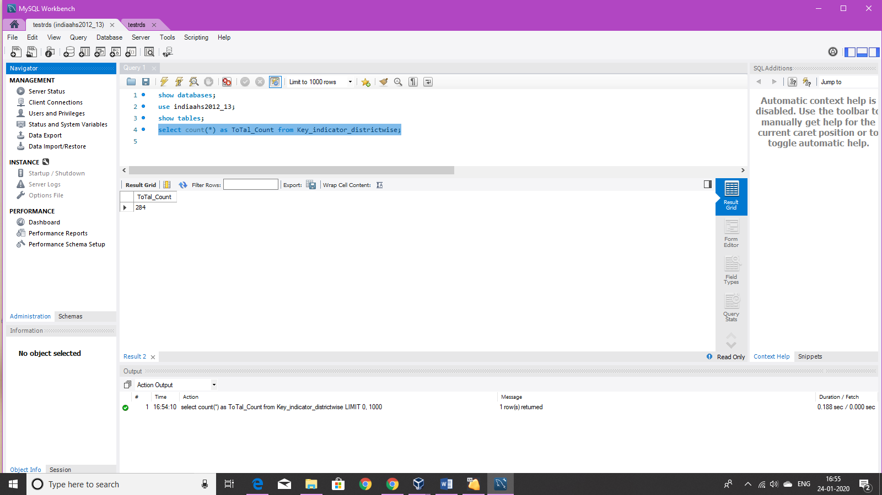

1. Run the below query on Hue

Select count(*) as Total_Count from indiaahs2012_13.key_indicator_districtwise;

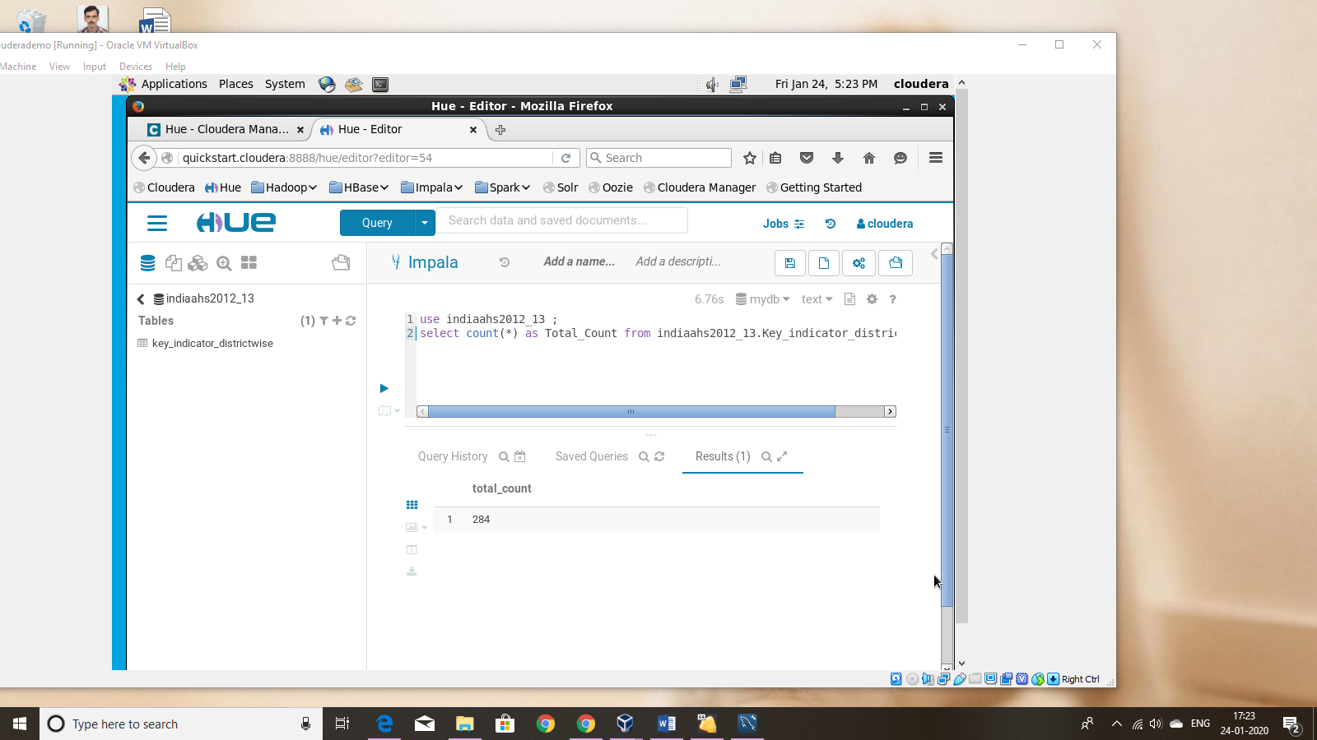

b) Query to select the top 10 rows and first 8 columns along with the screenshots of the data fetched by the query on MySQL Workbench and Hue

1. Query in Mysql workbench

select ID, State_Name, State_District_Name, AA_Sample_Units_Total, AA_Sample_Units_Rural, AA_Sample_Units_Urban,AA_Households_Total,AA_Households_Rural,

AA_Households_Urban,AA_Population_Total from Key_indicator_districtwise limit 10;

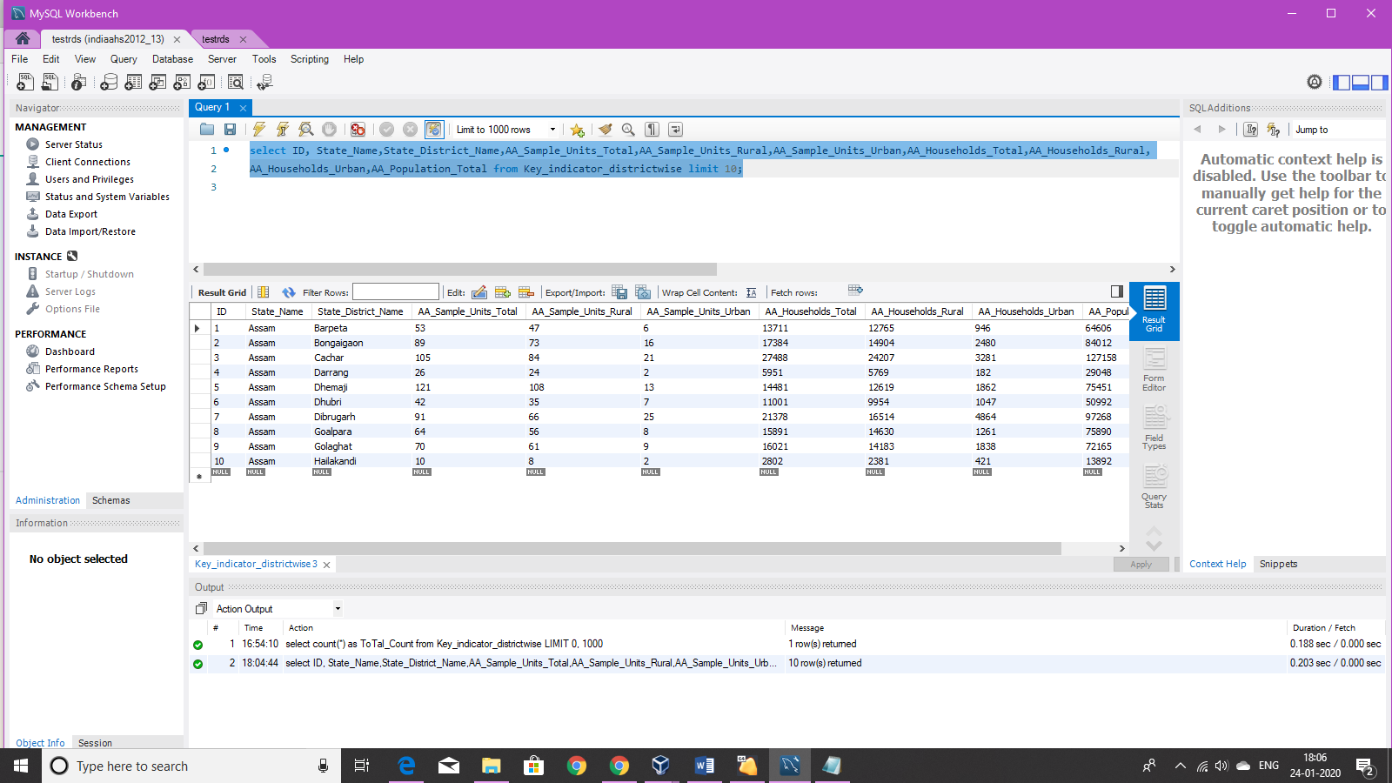

1. Query in Hue

select ID, State_Name,State_District_Name,AA_Sample_Units_Total,AA_Sample_Units_Rural,AA_Sample_Units_Urban,AA_Households_Total,AA_Households_Rural,

AA_Households_Urban,AA_Population_Total from indiaahs2012_13.key_indicator_districtwise limit 10;

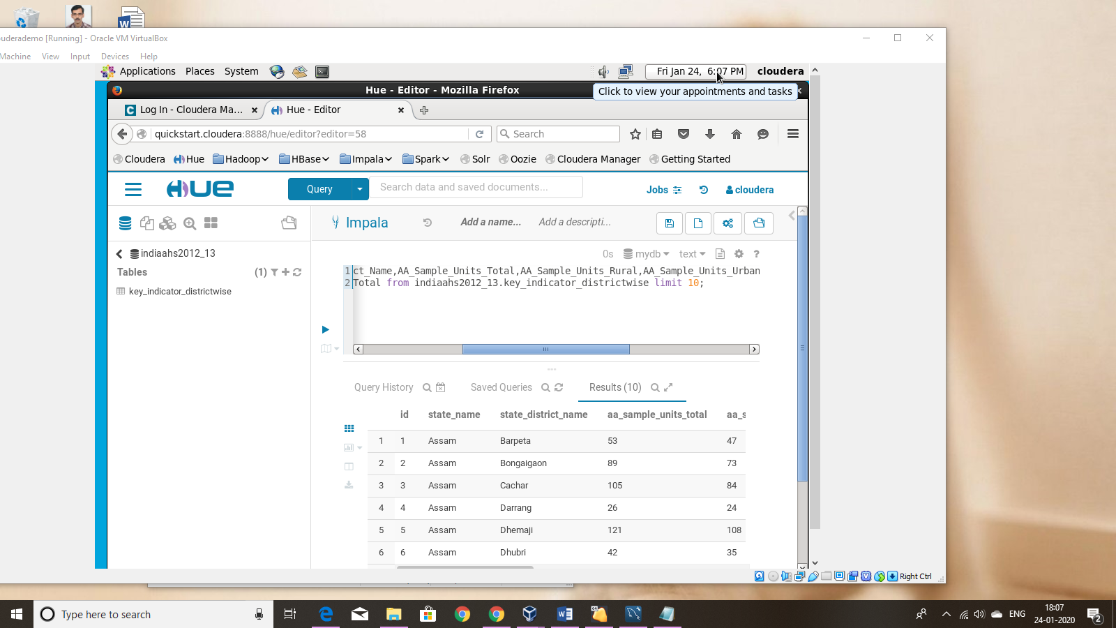

**Subset schema creation in Hive to support the analyses**

1. Columns used in the subset schema

state_name

state_district_name

population_per_household

sex_ratio

fertility_rate

child_mortality_rate

1. Storage Format used

ORC

1. Create and insert command for the default format

create table hive_analysis(‘ID’ int(11),`State_Name` varchar(100) ,`State_District_Name` varchar(100),`population_per_household` double, `Sex_ratio` double, `Fertlity_rate` double,`Child_Mortality_Rate` double ) row format delimited fields terminated by ',';

insert overwrite table hive_analysis select id,state_name,state_district_name

,round((aa_population_total/aa_households_total),1),cc_sex_ratio_all_ages_total,ll_total_fertility_rate_total, yy_under_five_mortality_rate_u5mr_total_person from indiaahs2012_13.key_indicator_districtwise;

1. Create and insert command for the formats such as ORC

create table hive_analysis_orc(ID int,State_Name varchar(100) ,State_District_Name varchar(100),population_per_household double, Sex_ratio double, Fertility_rate double,Child_Mortality_Rate double) stored as orc tblproperties("orc.compress"="SNAPPY");

insert overwrite table hive_analysis_orc select id,state_name,state_district_name

,round((aa_population_total/aa_households_total),1),cc_sex_ratio_all_ages_total,ll_total_fertility_rate_total, yy_under_five_mortality_rate_u5mr_total_person from indiaahs2012_13.key_indicator_districtwise;

1. Create and insert command for the Hive-HBase integrated table

create table hive_analysis_hbase(id int,State_Name varchar(100),State_District_Name varchar(100),population_per_household double, Sex_ratio double, Fertliity_rate double, Child_Mortality_Rate double)

STORED BY 'org.apache.hadoop.hive.hbase.HBaseStorageHandler' with serdeproperties

("hbase.columns.mapping"=":key,cf1:State_Name,cf2:State_District_name,cf3:population_per_household,cf4:Sex_ratio,cf5:Fertility_rate,cf6:Child_Mortality_Rate") tblproperties("hbase.table.name"="indiaahskeyindicator");

insert overwrite table hive_analysis_hbase select *from hive_analysis;

1. Screenshot of runtimes against each query given above for the default format, formats such as ORC format as well as Hive-Hbase integration

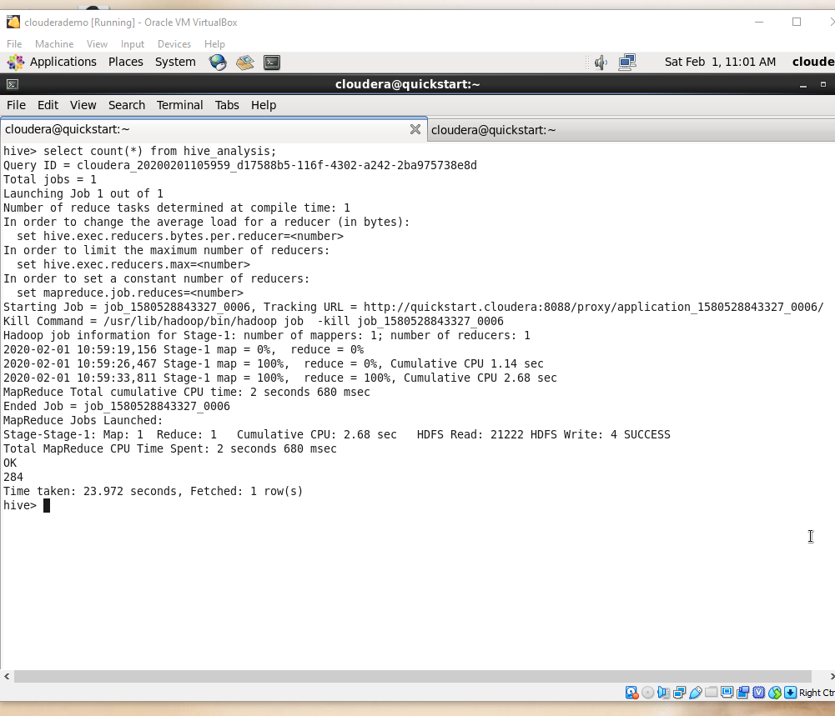

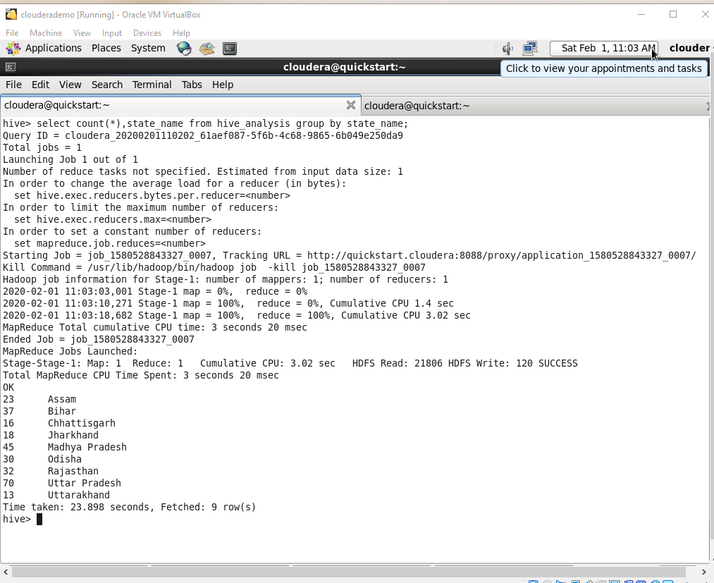

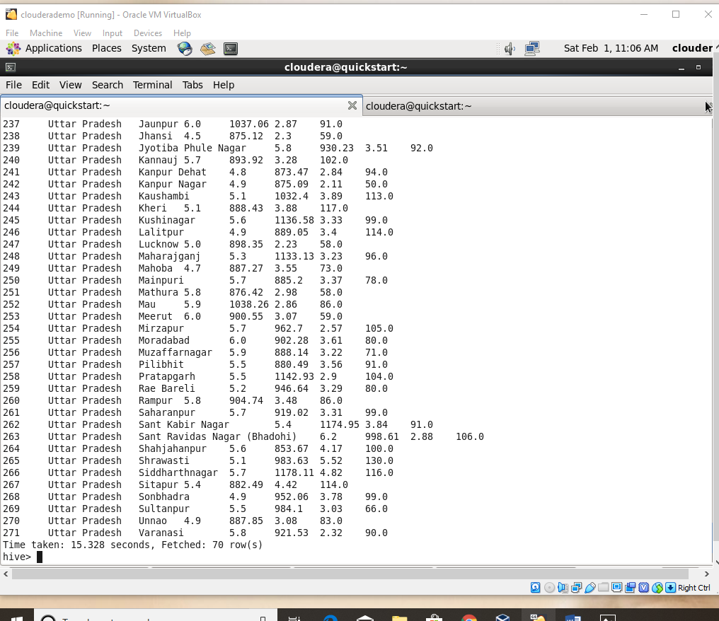

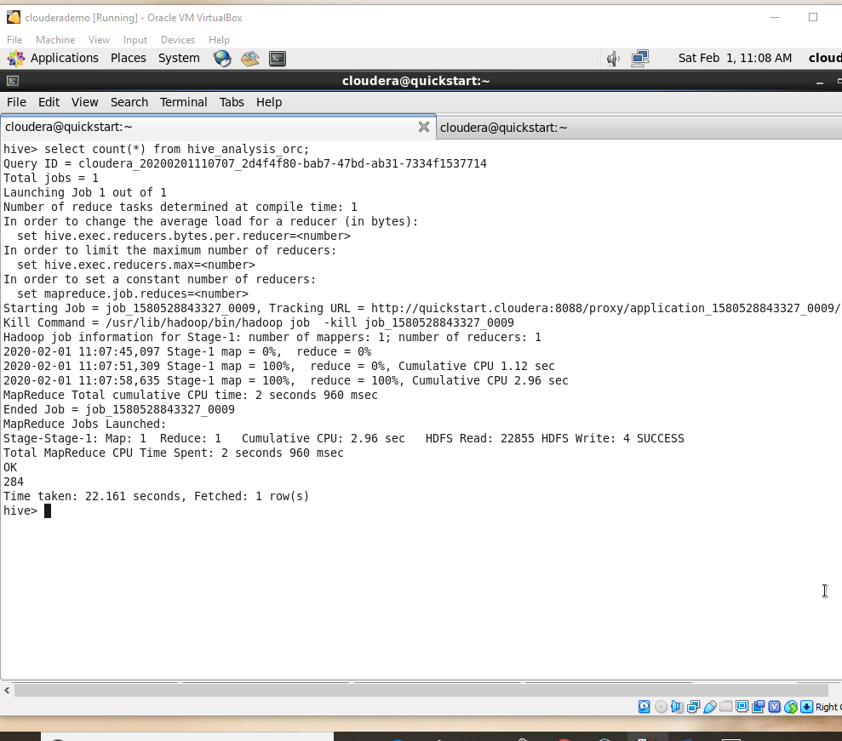

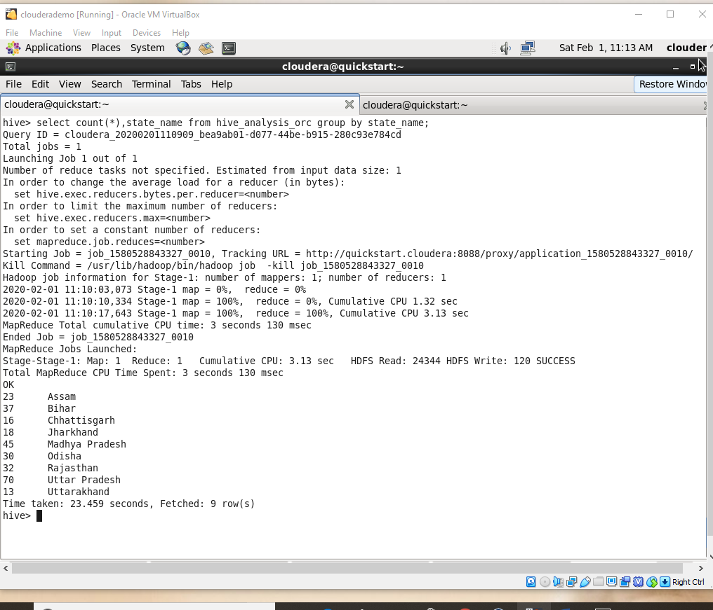

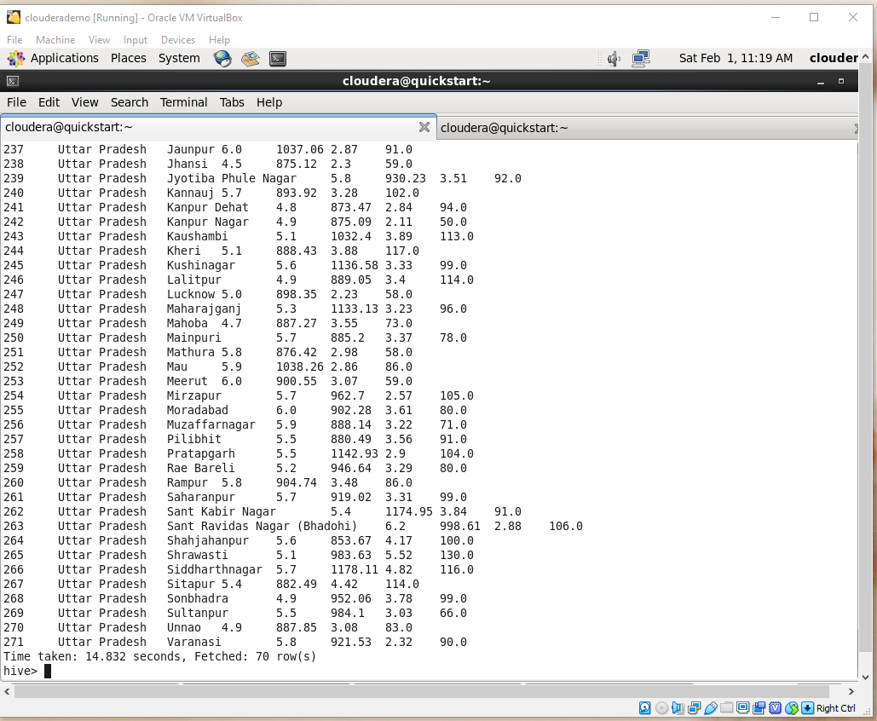

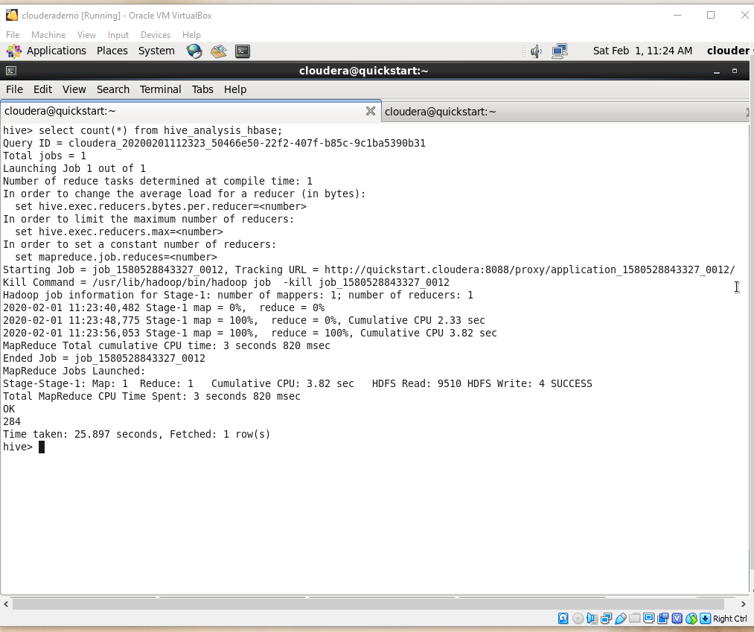

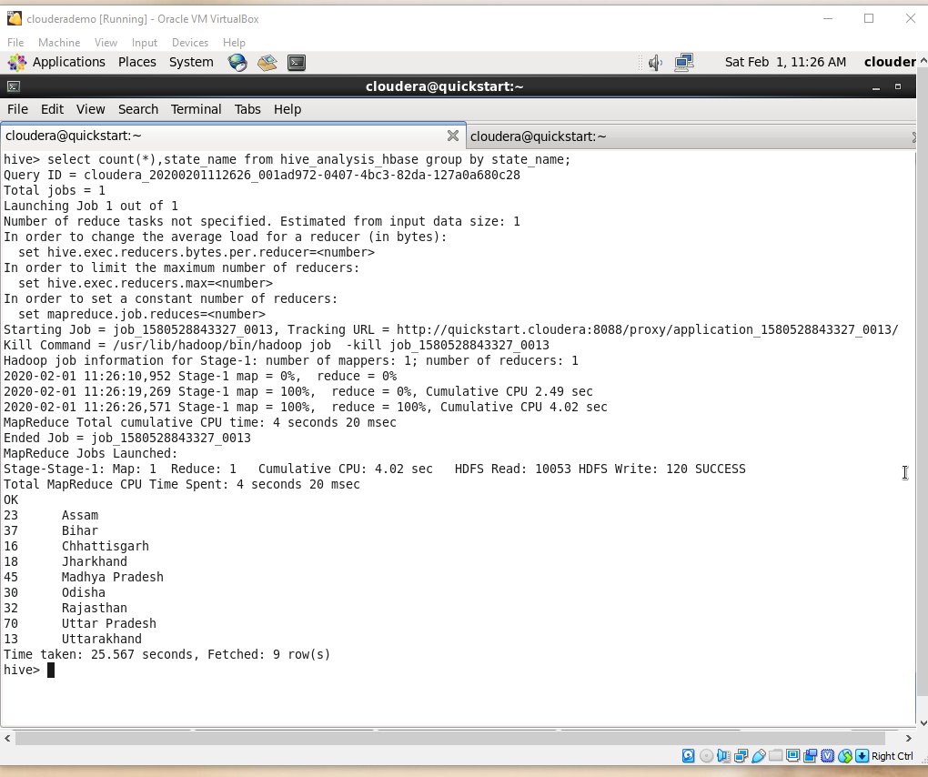

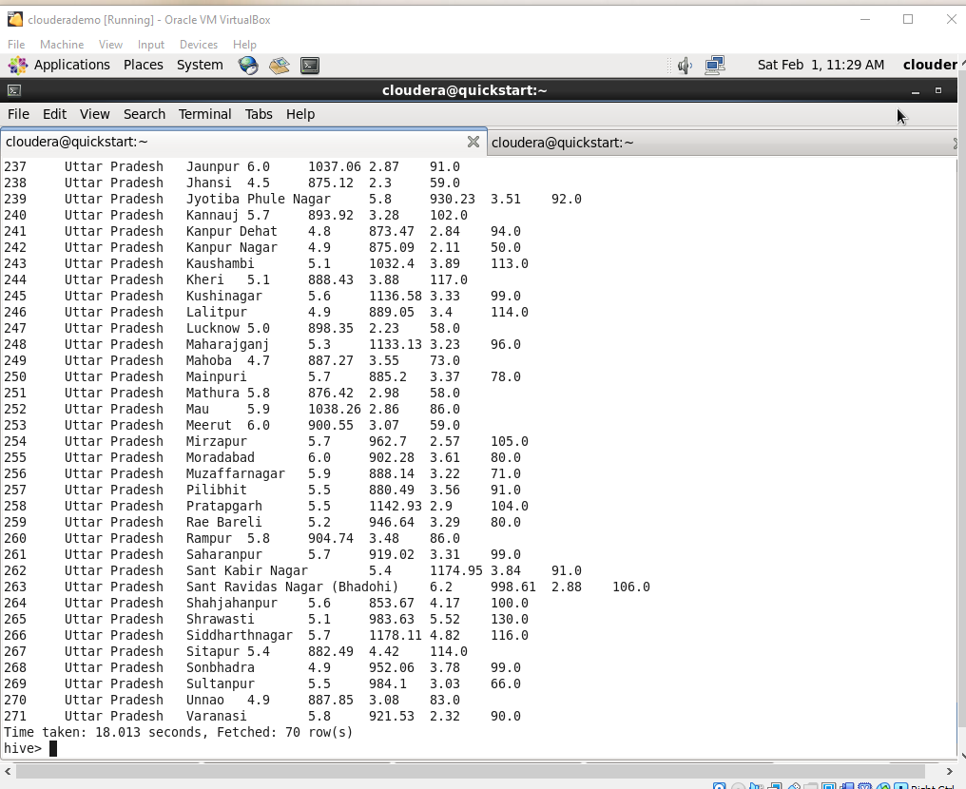

1. **Benchmarking performance on execution time results of query**

|  |  |  |  |
| --- | --- | --- | --- |
| Query | Default table | Orc table | Hive_habase integrated |
| 1 | 23.972 | 22.161 | 25.897 |
| 2 | 23.898 | 23.459 | 25.567 |
| 3 | 15.328 | 14.832 | 18.013 |

**From the above analysis it is understood that storing as orc is the best in execution time.**

1. Partitioned queries

create external table if not exists hive_analysis_part(`fertility_rate` double,`child_mortality_rate` double ) partitioned by (state_name varchar(100));

insert overwrite table hive_analysis_part partition(state_name) select fertlity_rate,child_mortality_rate ,state_name from hive_analysis where state_name in ('Uttar Pradesh','Bihar');

**The result of each analysis along with the query and the corresponding chart generated in Hue. Keep optimizations in mind**

1. The child mortality rate of Uttar Pradesh

Query - select state_name,round(avg(child_mortality_rate),1) as child_mortality_rate from hive_analysis_part where state_name='Uttar Pradesh'group by state_name;

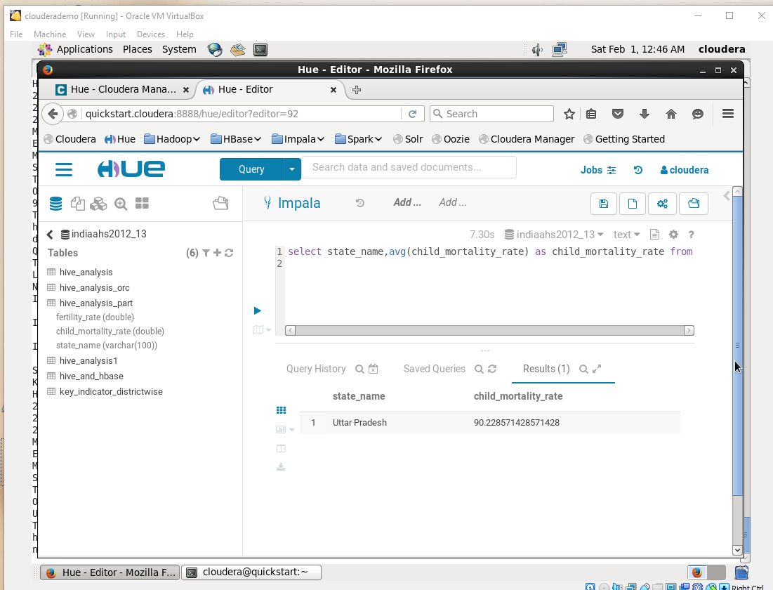

Query -Hive_hbase

select state_name,round(avg(child_mortality_rate),1) as child_mortality_rate from hive_analysis_hbase where state_name='Uttar Pradesh' group by state_name;

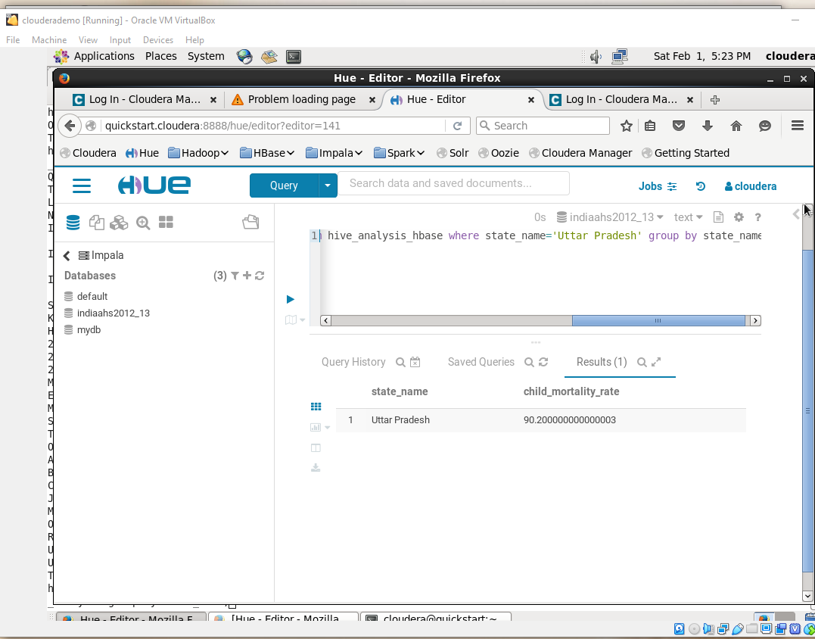

1. The fertility rate of Bihar

Query - select state_name,avg(fertility_rate) as fertilityy_rate from hive_analysis_part where state_name='Bihar'group by state_name;

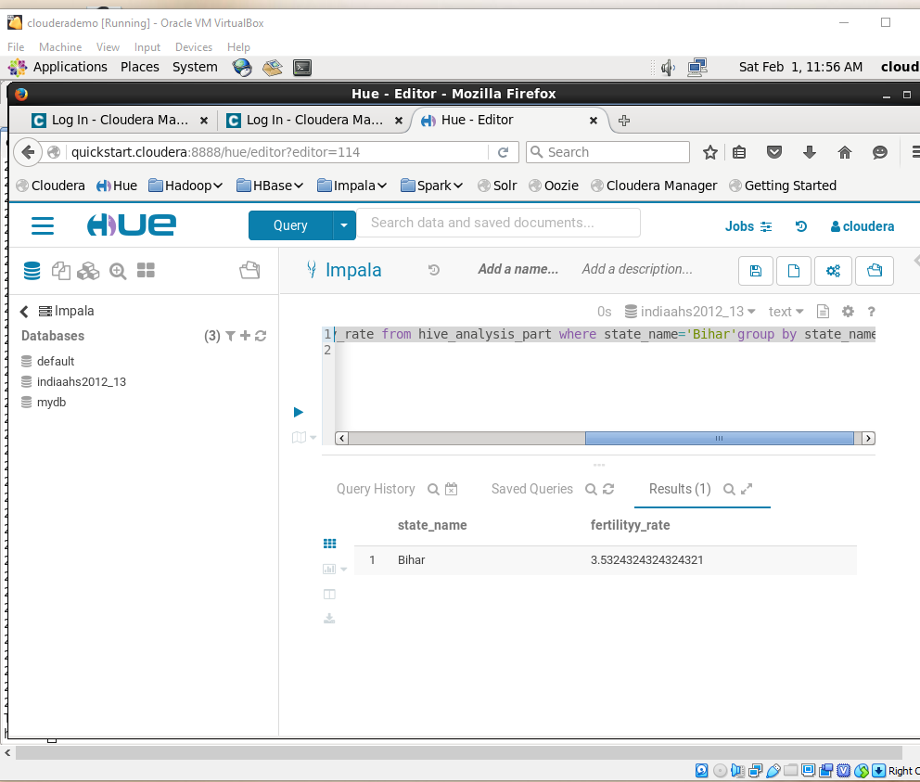

Query_hive hbae

select state_name,avg( fertliity_rate ) as fertilityy_rate from hive_analysis_hbase where state_name='Bihar'group by state_name;

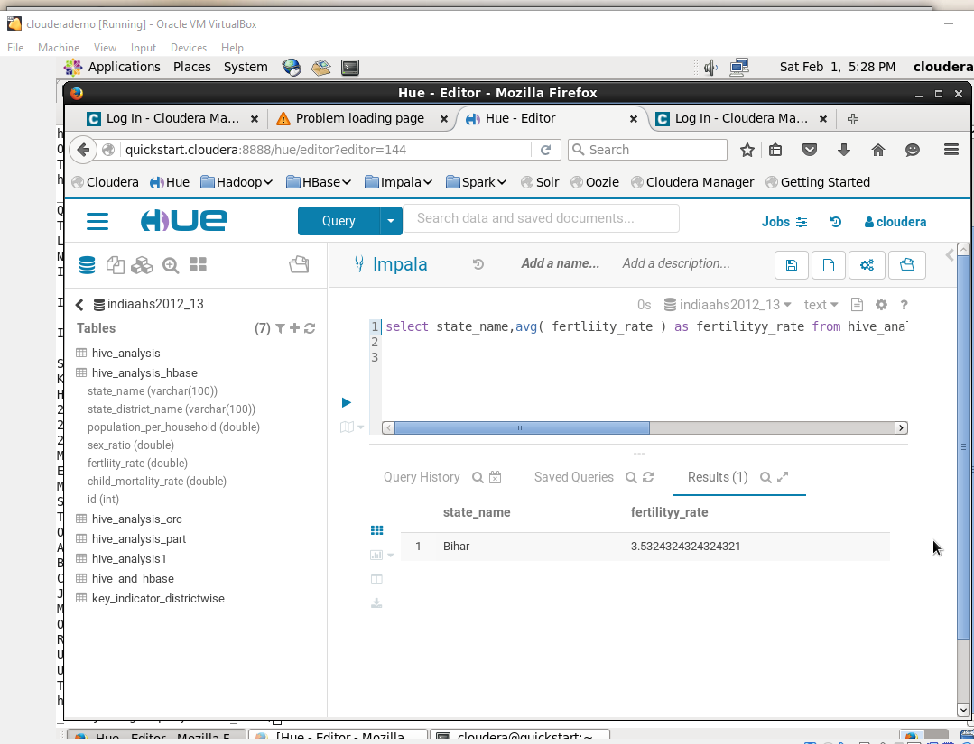

3.State wise child mortality rate and state wise fertility rate and does high fertility correlate with high child mortality?

Query - select state_name,avg(child_mortality_rate) as child_mortality_rate from hive_analysis group by state_name;

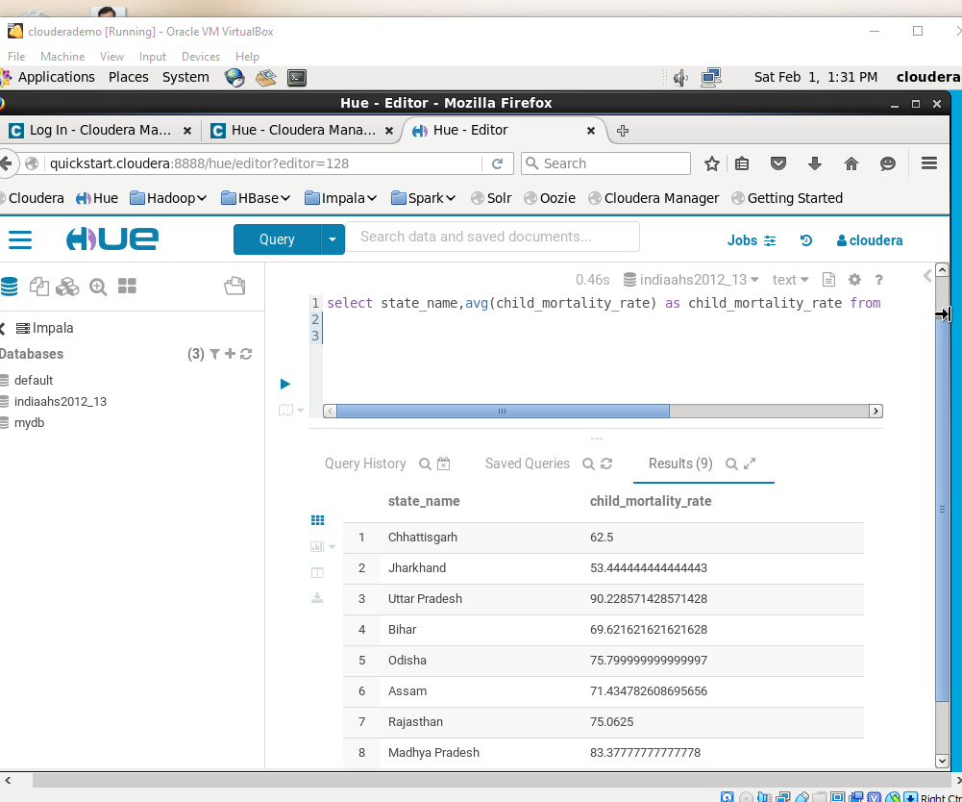

Query - select state_name,avg(child_mortality_rate) as child_mortality_rate from hive_analysis_hbase group by state_name;

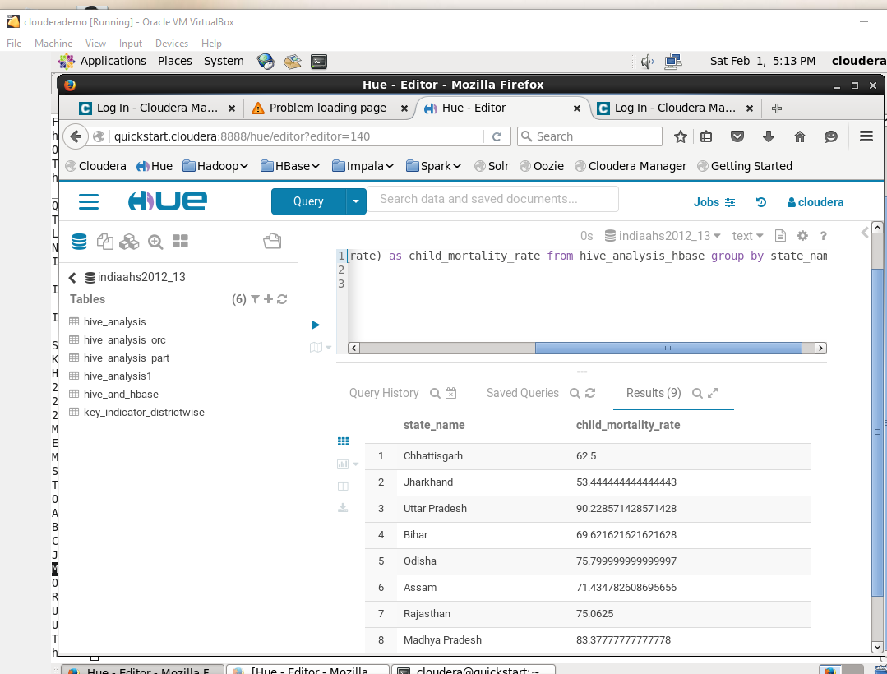

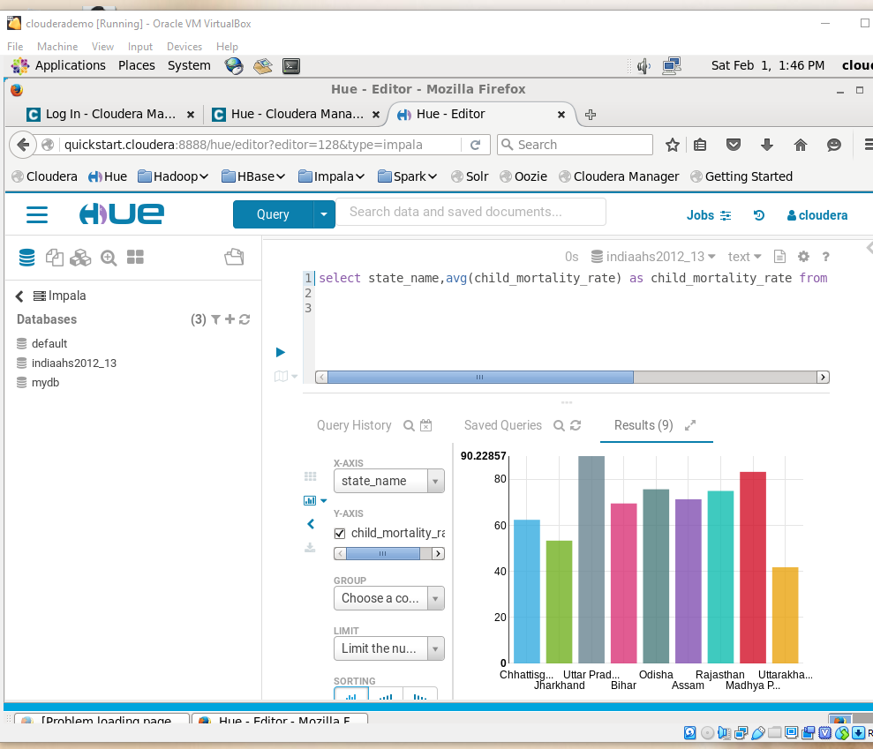

Query - select state_name,avg(fertility_rate) as fertility_rate from hive_analysis group by state_name;

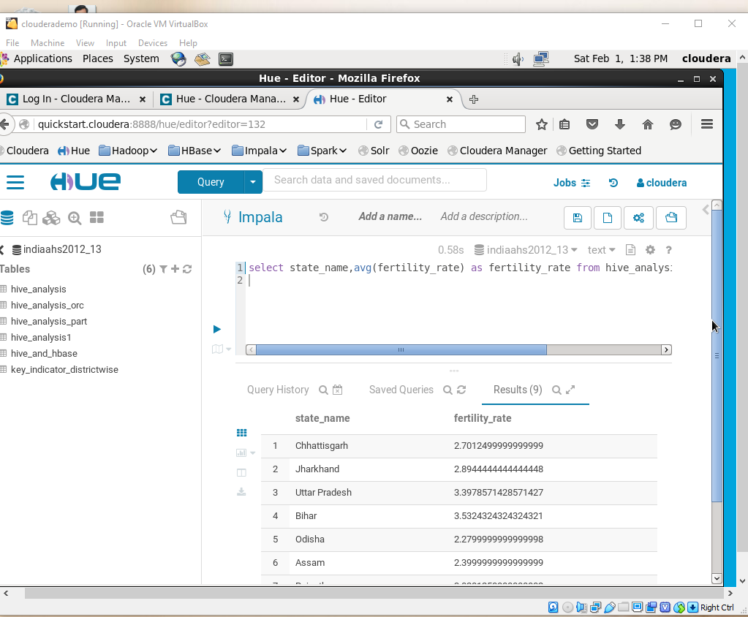

Query hive_hbase- select state_name,avg(fertility_rate) as fertility_rate from hive_analysis_hbase group by state_name;

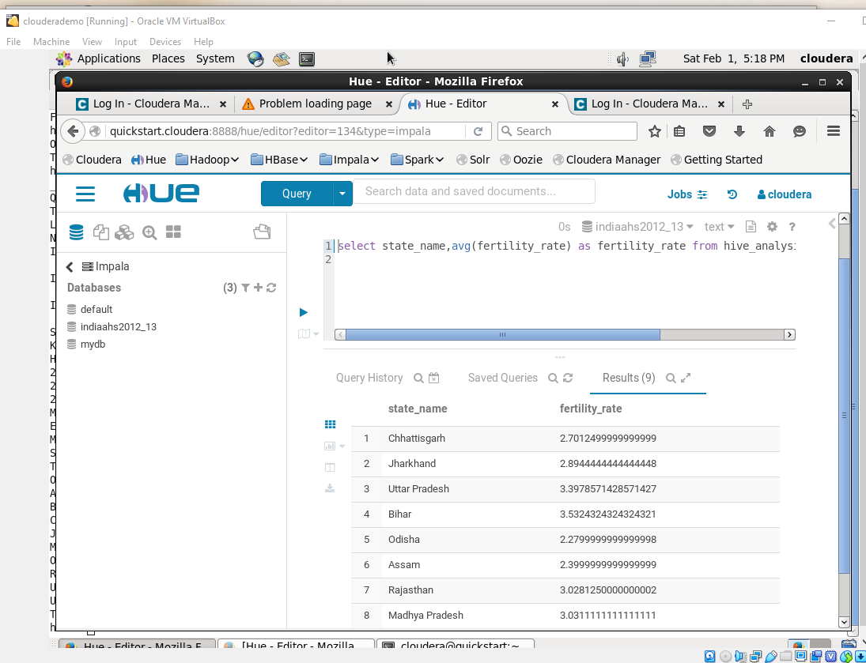

Chart

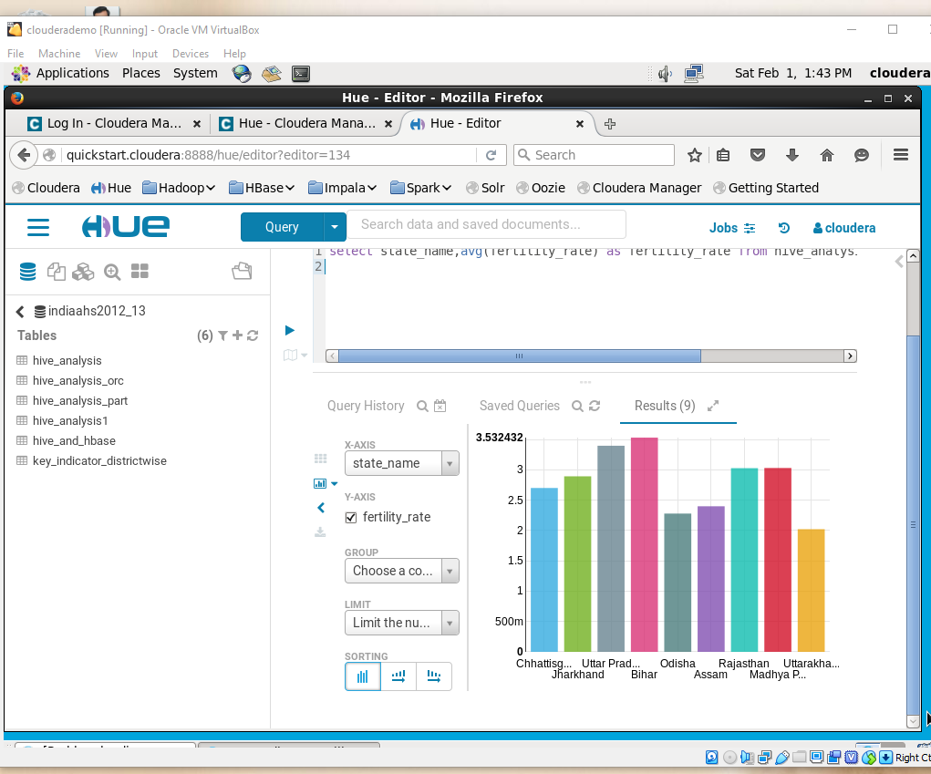

select state_name, corr(child_mortality_rate,fertility_rate)as cor_data from hive_analysis group by state_name;

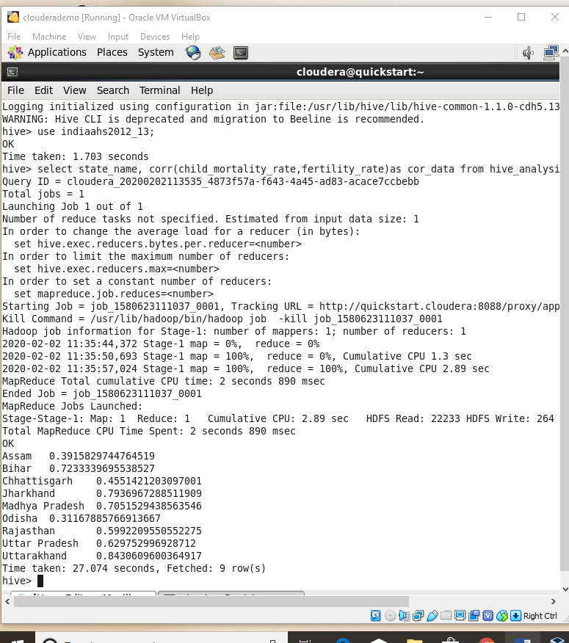

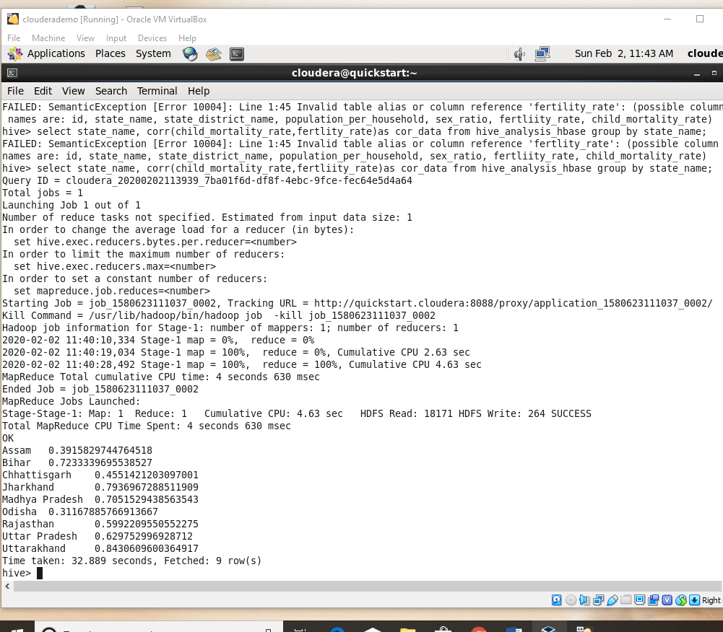

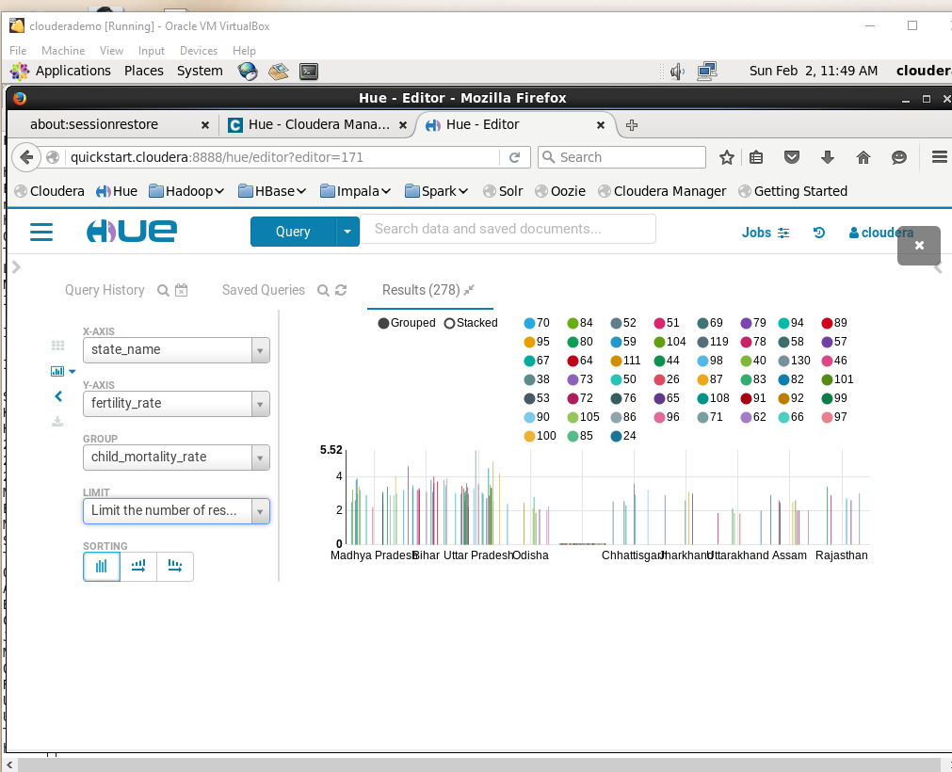

4. Find top 2 districts per state with the highest population per household

Query - select s.state_name,s.state_district_name ,s.population_per_household,s.rank from (select state_name, state_district_name,population_per_household,rank() over (partition by state_name order by population_per_household desc) as rank from

hive_analysis )s where s.rank <= 2;

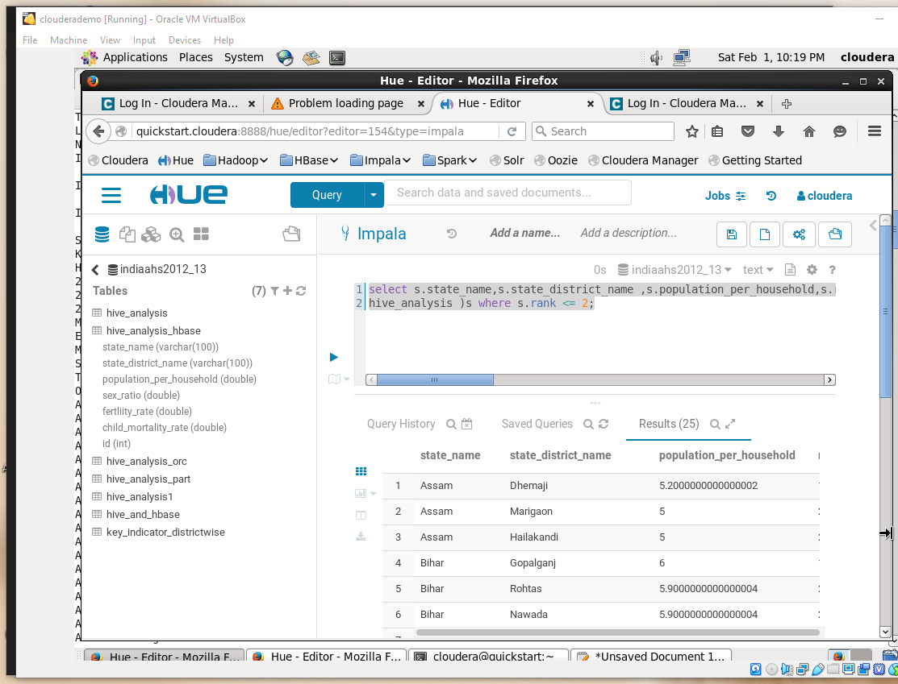

Query_hive_hbase - select s.state_name,s.state_district_name ,s.population_per_household,s.rank from (select state_name, state_district_name,population_per_household,rank() over (partition by state_name order by population_per_household desc) as rank from

hive_analysis_hbase )s where s.rank <= 2;

